Date: 10/04/26
📊 Final Count:
🟢 Bullish | 180
🔴 Bearish | 6
Total | 186

🟢 BULLISH TRADES --- 180
1 | 360ONE26AprFUT
2 | AUBANK26AprFUT
3 | ADANIENSOL26AprFUT
4 | ADANIENT26AprFUT
5 | ADANIGREEN26AprFUT
6 | ADANIPORTS26AprFUT
7 | ABCAPITAL26AprFUT
8 | AMBUJACEM26AprFUT
9 | ANGELONE26AprFUT
10 | APOLLOHOSP26AprFUT
11 | AXISBANK26AprFUT
12 | BAJAJFINSV26AprFUT
13 | BANKBARODA26AprFUT
14 | BANKINDIA26AprFUT
15 | BDL26AprFUT
16 | BEL26AprFUT
17 | BHARATFORG26AprFUT
18 | BHEL26AprFUT
19 | BOSCHLTD26AprFUT
20 | CGPOWER26AprFUT
21 | INDIGO26AprFUT
22 | JINDALSTEL26AprFUT
23 | JIOFIN26AprFUT
24 | LTF26AprFUT
25 | LT26AprFUT
26 | LAURUSLABS26AprFUT
27 | MANAPPURAM26AprFUT
28 | MARUTI26AprFUT
29 | MFSL26AprFUT
30 | MAZDOCK26AprFUT
31 | MPHASIS26AprFUT
32 | MUTHOOTFIN26AprFUT
33 | NHPC26AprFUT
34 | NTPC26AprFUT
35 | OBEROIRLTY26AprFUT
36 | ONGC26AprFUT
37 | PAYTM26AprFUT
38 | POLICYBZR26AprFUT
39 | PRESTIGE26AprFUT
40 | PNB26AprFUT
41 | CANBK26AprFUT
42 | CIPLA26AprFUT
43 | COALINDIA26AprFUT
44 | CAMS26AprFUT
45 | DLF26AprFUT
46 | DABUR26AprFUT
47 | DALBHARAT26AprFUT
48 | DRREDDY26AprFUT
49 | NYKAA26AprFUT
50 | GAIL26AprFUT
51 | GODREJPROP26AprFUT
52 | GRASIM26AprFUT
53 | HDFCAMC26AprFUT
54 | HDFCBANK26AprFUT
55 | HAL26AprFUT
56 | ICICIBANK26AprFUT
57 | ICICIGI26AprFUT
58 | IDFCFIRSTB26AprFUT
59 | ITC26AprFUT
60 | INDIANB26AprFUT
61 | SIEMENS26AprFUT
62 | SOLARINDS26AprFUT
63 | SONACOMS26AprFUT
64 | SUPREMEIND26AprFUT
65 | TVSMOTOR26AprFUT
66 | TMPV26AprFUT
67 | TATASTEEL26AprFUT
68 | PHOENIXLTD26AprFUT
69 | TITAN26AprFUT
70 | TRENT26AprFUT
71 | ULTRACEMCO26AprFUT
72 | UNIONBANK26AprFUT
73 | VBL26AprFUT
74 | IDEA26AprFUT
75 | YESBANK26AprFUT
76 | ZYDUSLIFE26AprFUT
77 | AUROPHARMA26AprFUT
78 | GLENMARK26AprFUT
79 | IRFC26AprFUT
80 | IREDA26AprFUT
81 | INDUSINDBK26AprFUT
82 | INOXWIND26AprFUT
83 | MANKIND26AprFUT
84 | RBLBANK26AprFUT
85 | RECLTD26AprFUT
86 | SHREECEM26AprFUT
87 | MOTHERSON26AprFUT
88 | SHRIRAMFIN26AprFUT
89 | TORNTPHARM26AprFUT
90 | ABB26AprFUT
91 | BAJAJ-AUTO26AprFUT
92 | HINDUNILVR26AprFUT
93 | KALYANKJIL26AprFUT
94 | PETRONET26AprFUT
95 | SAIL26AprFUT
96 | HINDALCO26AprFUT
97 | HINDZINC26AprFUT
98 | KPITTECH26AprFUT
99 | MCX26AprFUT
100 | PAGEIND26AprFUT
101 | TATATECH26AprFUT
102 | APLAPOLLO26AprFUT
103 | COLPAL26AprFUT
104 | CONCOR26AprFUT
105 | ETERNAL26AprFUT
106 | HDFCLIFE26AprFUT
107 | ICICIPRULI26AprFUT
108 | KAYNES26AprFUT
109 | LTM26AprFUT
110 | NUVAMA26AprFUT
111 | TATACONSUM26AprFUT
112 | TATAELXSI26AprFUT
113 | UPL26AprFUT
114 | UNITDSPR26AprFUT
115 | VEDL26AprFUT
116 | DMART26AprFUT
117 | BSE26AprFUT
118 | BPCL26AprFUT
119 | BLUESTARCO26AprFUT
120 | GMRAIRPORT26AprFUT
121 | IEX26AprFUT
122 | KEI26AprFUT
123 | POWERINDIA26AprFUT
124 | NATIONALUM26AprFUT
125 | PFC26AprFUT
126 | NESTLEIND26AprFUT
127 | PIDILITIND26AprFUT
128 | POWERGRID26AprFUT
129 | DIXON26AprFUT
130 | LICHSGFIN26AprFUT
131 | PNBHOUSING26AprFUT
132 | PERSISTENT26AprFUT
133 | INDHOTEL26AprFUT
134 | UNOMINDA26AprFUT
135 | VOLTAS26AprFUT
136 | BANDHANBNK26AprFUT
137 | NBCC26AprFUT
138 | TIINDIA26AprFUT
139 | FORTIS26AprFUT
140 | PGEL26AprFUT
141 | KOTAKBANK26AprFUT
142 | NMDC26AprFUT
143 | ALKEM26AprFUT
144 | ASTRAL26AprFUT
145 | BAJFINANCE26AprFUT
146 | DELHIVERY26AprFUT
147 | SBILIFE26AprFUT
148 | BHARTIARTL26AprFUT
149 | INDUSTOWER26AprFUT
150 | JSWSTEEL26AprFUT
151 | LICI26AprFUT
152 | RELIANCE26AprFUT
153 | TATAPOWER26AprFUT
154 | TORNTPOWER26AprFUT
155 | SAMMAANCAP26AprFUT
156 | MARICO26AprFUT
157 | WIPRO26AprFUT
158 | ASHOKLEY26AprFUT
159 | ASIANPAINT26AprFUT
160 | CDSL26AprFUT
161 | CHOLAFIN26AprFUT
162 | CROMPTON26AprFUT
163 | EXIDEIND26AprFUT
164 | HEROMOTOCO26AprFUT
165 | HINDPETRO26AprFUT
166 | IOC26AprFUT
167 | KFINTECH26AprFUT
168 | MAXHEALTH26AprFUT
169 | OFSS26AprFUT
170 | PIIND26AprFUT
171 | PPLPHARMA26AprFUT
172 | RVNL26AprFUT
173 | SUZLON26AprFUT
174 | DIVISLAB26AprFUT
175 | EICHERMOT26AprFUT
176 | LODHA26AprFUT
177 | M&M26AprFUT
178 | PATANJALI26AprFUT
179 | SBICARD26AprFUT
180 | AMBER26AprFUT
🔴 BEARISH TRADES --- 6
1 | BRITANNIA26AprFUT
2 | BIOCON26AprFUT
3 | COFORGE26AprFUT
4 | INFY26AprFUT
5 | TCS26AprFUT
6 | TECHM26AprFUT

Trade Taken
🟢 BULLISH SIGNAL --- ADANIENSOL26AprFUT

Nifty Bias : 🔴 SHORT — Counter Trend ⚠️
Crossover : 2026-04-06 10:45 (4 days ago)
Pullback : 2026-04-09 15:15
Low ₹1072.05 ≤ EMA9(Low) ₹1073.42
High ₹1084.1 (breakout level)
Confirm : 2026-04-10 09:15 (+1 candle)
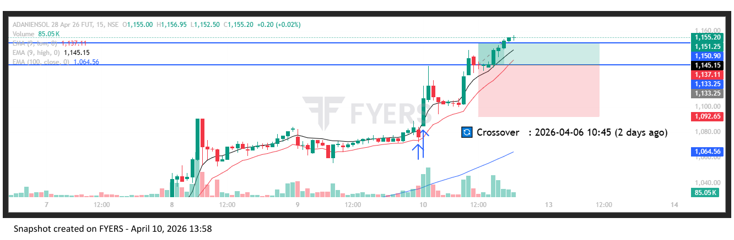
🟢 BULLISH SIGNAL --- ADANIGREEN26AprFUT

Nifty Bias : 🔴 SHORT — Counter Trend ⚠️
Crossover : 2026-04-02 15:15 (8 days ago)
Pullback : 2026-04-09 15:15
Low ₹1044 ≤ EMA9(Low) ₹1045.3
High ₹1051.1 (breakout level)
Confirm : 2026-04-10 09:15 (+1 candle)
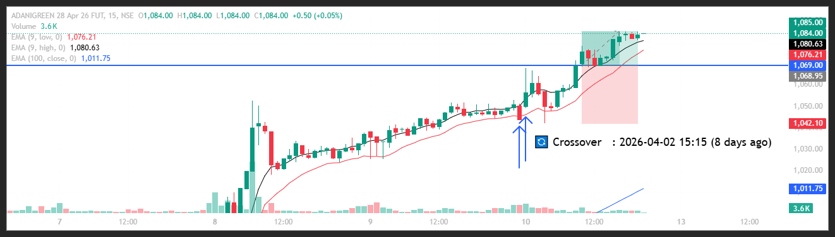
🟢 BULLISH SIGNAL --- ANGELONE26AprFUT

Nifty Bias : 🔴 SHORT — Counter Trend ⚠️
Crossover : 2026-04-02 14:00 (8 days ago)
Pullback : 2026-04-09 14:45
Low ₹276.51 ≤ EMA9(Low) ₹276.81
High ₹277.99 (breakout level)
Confirm : 2026-04-10 09:15 (+3 candle)
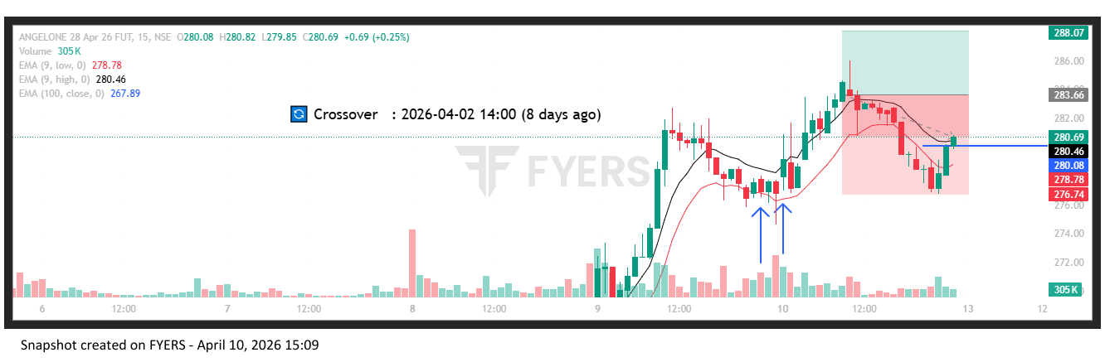
🟢 BULLISH SIGNAL --- BHEL26AprFUT

Nifty Bias : 🔴 SHORT — Counter Trend ⚠️
Crossover : 2026-04-07 13:45 (3 days ago)
Pullback : 2026-04-09 15:00
Low ₹276.45 ≤ EMA9(Low) ₹276.67
High ₹278.2 (breakout level)
Confirm : 2026-04-10 09:15 (+2 candle)
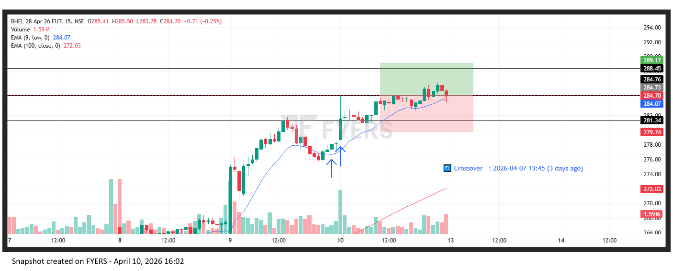
🟢 BULLISH SIGNAL --- DLF26AprFUT

Nifty Bias : 🟢 LONG — Aligned ✅
Crossover : 2026-04-06 09:45 (4 days ago)
Pullback : 2026-04-09 14:45
Low ₹563.6 ≤ EMA9(Low) ₹564.01
High ₹565.85 (breakout level)
Confirm : 2026-04-10 09:15 (+3 candle)
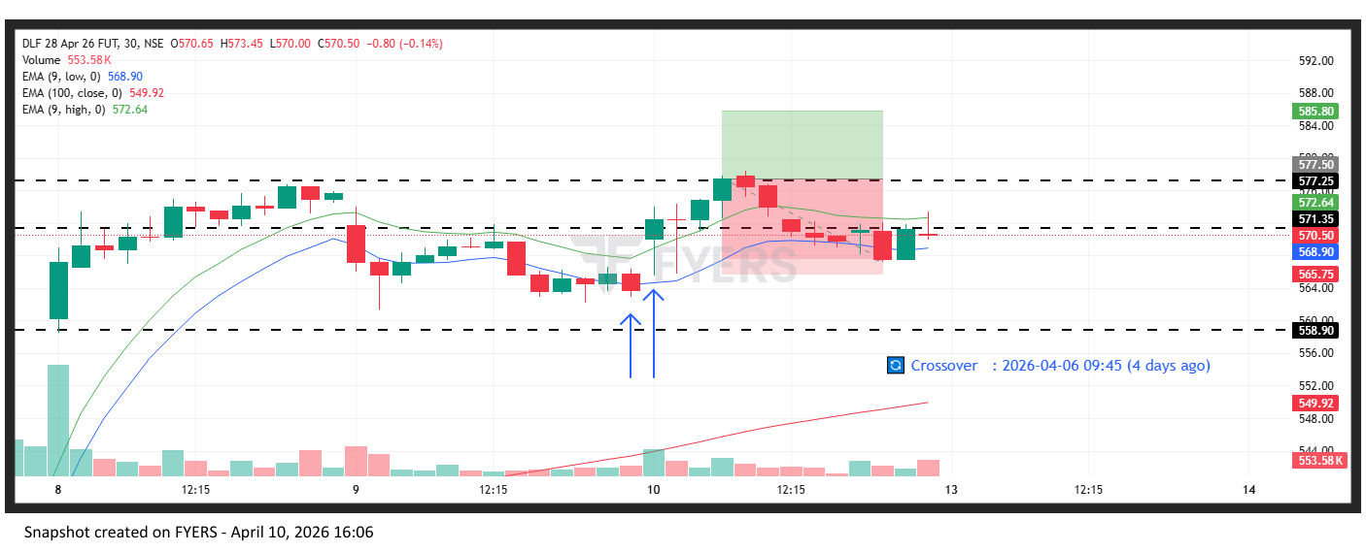
🟢 BULLISH SIGNAL --- DRREDDY26AprFUT

Nifty Bias : 🟢 LONG — Aligned ✅
Crossover : 2026-04-09 11:45 (a day ago)
Pullback : 2026-04-09 15:00
Low ₹1213.6 ≤ EMA9(Low) ₹1213.72
High ₹1218.5 (breakout level)
Confirm : 2026-04-10 09:15 (+2 candle)
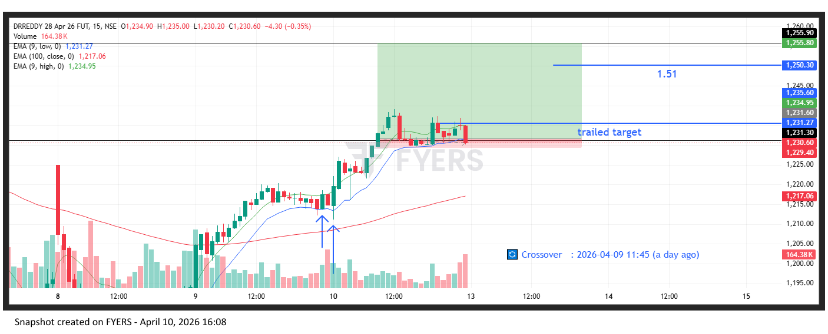
🟢 BULLISH SIGNAL --- GODREJPROP26AprFUT

Nifty Bias : 🟢 LONG — Aligned ✅
Crossover : 2026-04-06 10:00 (4 days ago)
Pullback : 2026-04-09 15:00
Low ₹1693.5 ≤ EMA9(Low) ₹1696.99
High ₹1705.6 (breakout level)
Confirm : 2026-04-10 09:15 (+2 candle)
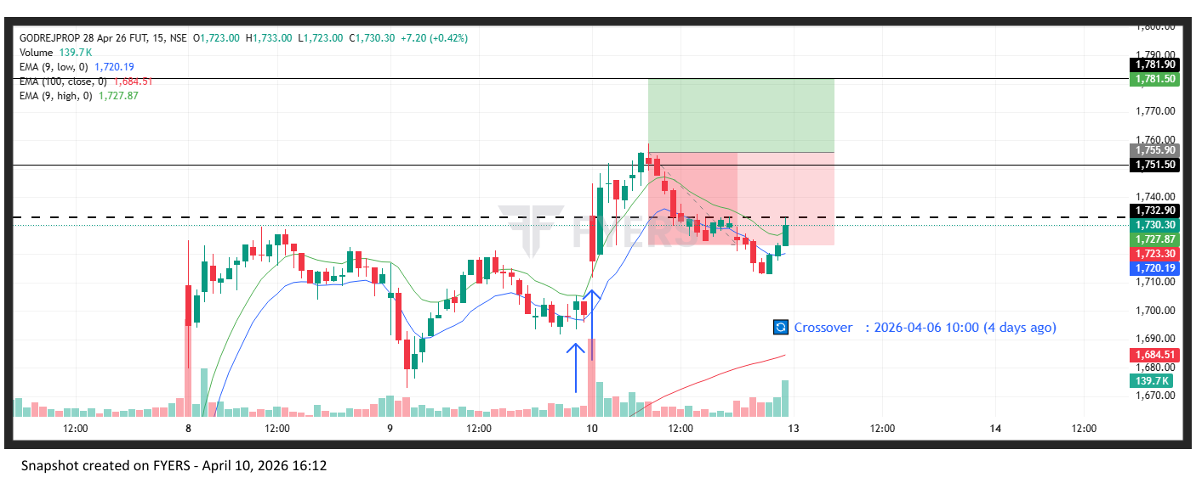
🟢 BULLISH SIGNAL --- SIEMENS26AprFUT

Nifty Bias : 🟢 LONG — Aligned ✅
Crossover : 2026-04-06 13:30 (4 days ago)
Pullback : 2026-04-09 15:00
Low ₹3225.4 ≤ EMA9(Low) ₹3226.2
High ₹3244.9 (breakout level)
Confirm : 2026-04-10 09:15 (+2 candle)
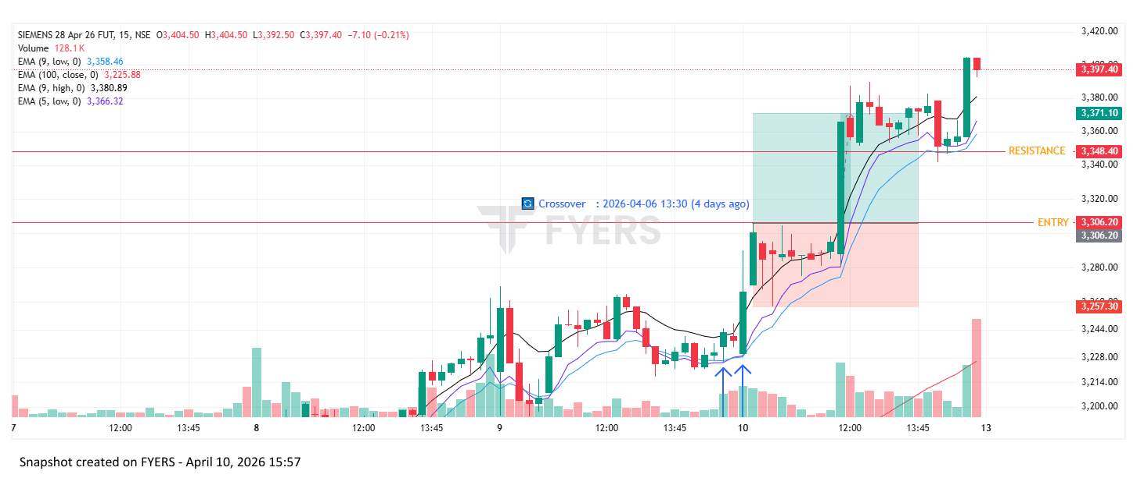
🟢 BULLISH SIGNAL --- TVSMOTOR26AprFUT

Nifty Bias : 🟢 LONG — Aligned ✅
Crossover : 2026-04-06 10:00 (4 days ago)
Pullback : 2026-04-09 15:15
Low ₹3721.5 ≤ EMA9(Low) ₹3724.29
High ₹3751.2 (breakout level)
Confirm : 2026-04-10 09:15 (+1 candle)
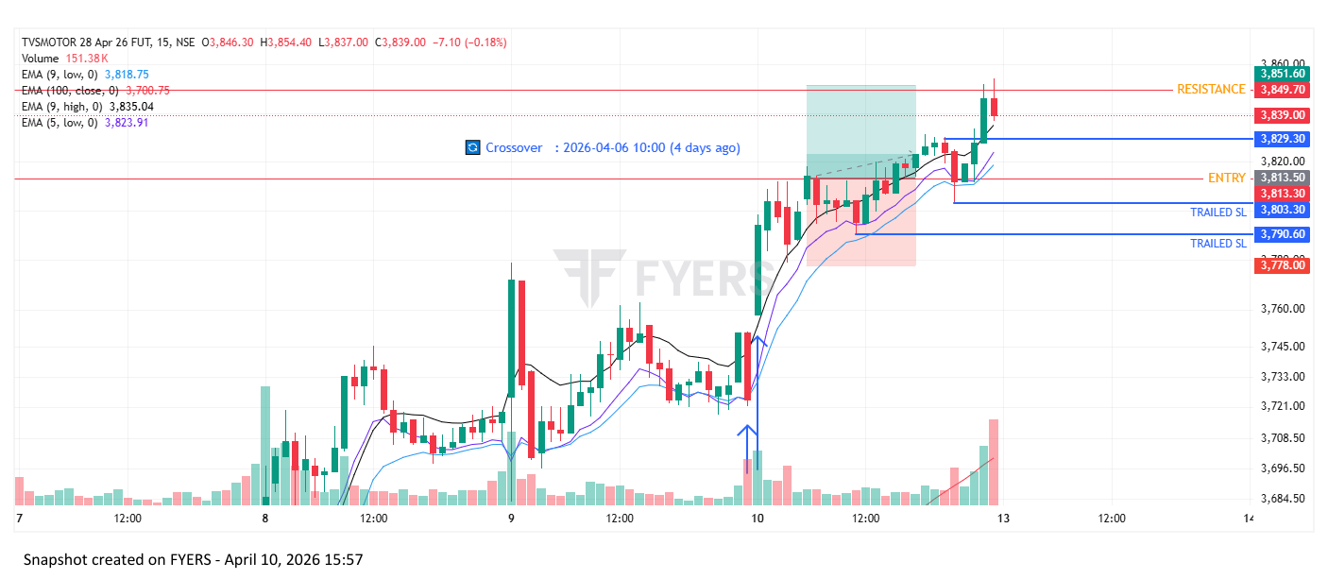
🟢 BULLISH SIGNAL --- PHOENIXLTD26AprFUT

Nifty Bias : 🟢 LONG — Aligned ✅
Crossover : 2026-04-06 10:15 (4 days ago)
Pullback : 2026-04-09 15:15
Low ₹1697.2 ≤ EMA9(Low) ₹1711.42
High ₹1715 (breakout level)
Confirm : 2026-04-10 09:15 (+1 candle)
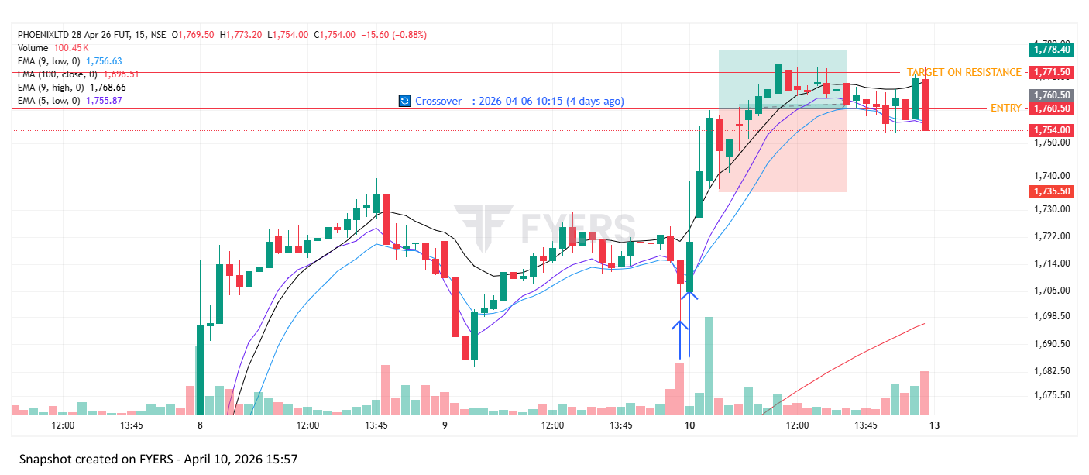
🟢 BULLISH SIGNAL --- POWERINDIA26AprFUT

Nifty Bias : 🟢 LONG — Aligned ✅
Crossover : 2026-04-08 09:15 (2 days ago)
Pullback : 2026-04-10 10:30
Low ₹27550 ≤ EMA9(Low) ₹27551.35
High ₹27725 (breakout level)
Confirm : 2026-04-10 11:00 (+2 candle)
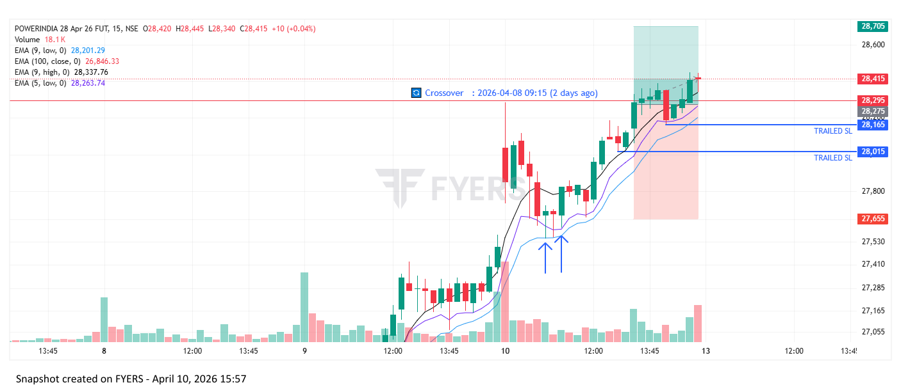

Trade Not Taken
🟢 BULLISH SIGNAL --- 360ONE26AprFUT

Nifty Bias : 🔴 SHORT — Counter Trend ⚠️
Crossover : 2026-04-08 09:45 (2 days ago)
Pullback : 2026-04-09 15:00
Low ₹998.75 ≤ EMA9(Low) ₹999.03
High ₹1002.15 (breakout level)
Confirm : 2026-04-10 09:15 (+2 candle)
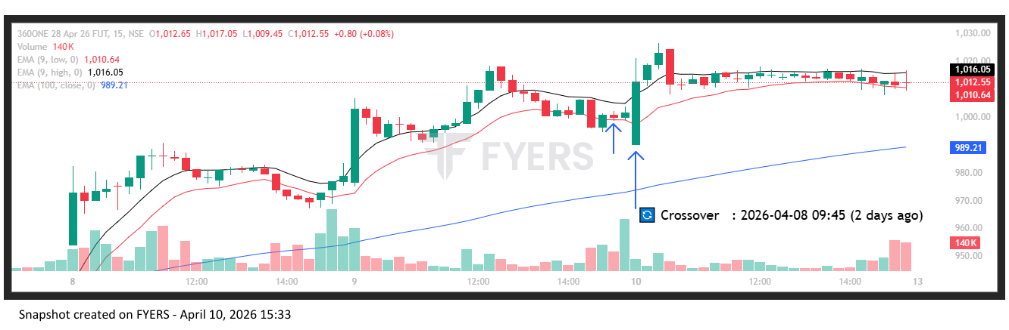
🟢 BULLISH SIGNAL --- AUBANK26AprFUT

Nifty Bias : 🔴 SHORT — Counter Trend ⚠️
Crossover : 2026-04-06 12:45 (4 days ago)
Pullback : 2026-04-09 15:15
Low ₹961.1 ≤ EMA9(Low) ₹963.08
High ₹965.9 (breakout level)
Confirm : 2026-04-10 09:15 (+1 candle)
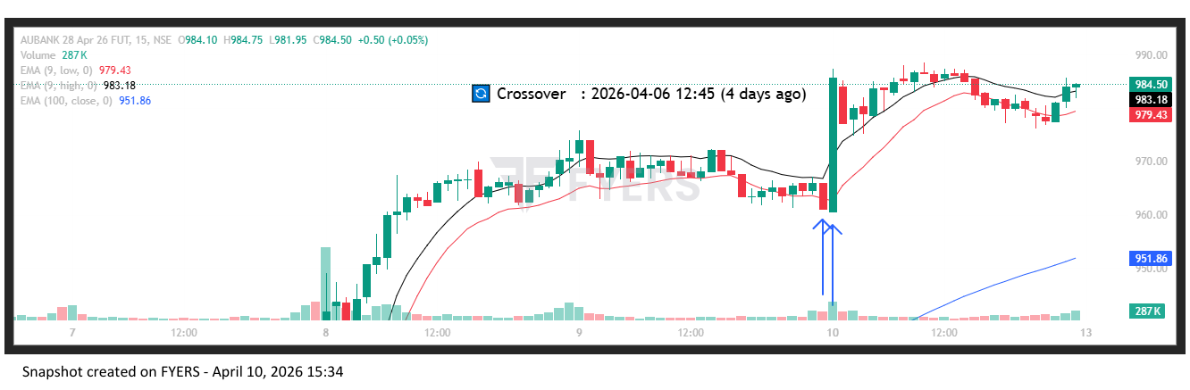
🟢 BULLISH SIGNAL --- ADANIENT26AprFUT

Nifty Bias : 🔴 SHORT — Counter Trend ⚠️
Crossover : 2026-04-06 12:00 (4 days ago)
Pullback : 2026-04-09 15:00
Low ₹2043.5 ≤ EMA9(Low) ₹2047.14
High ₹2055.8 (breakout level)
Confirm : 2026-04-10 09:15 (+2 candle)
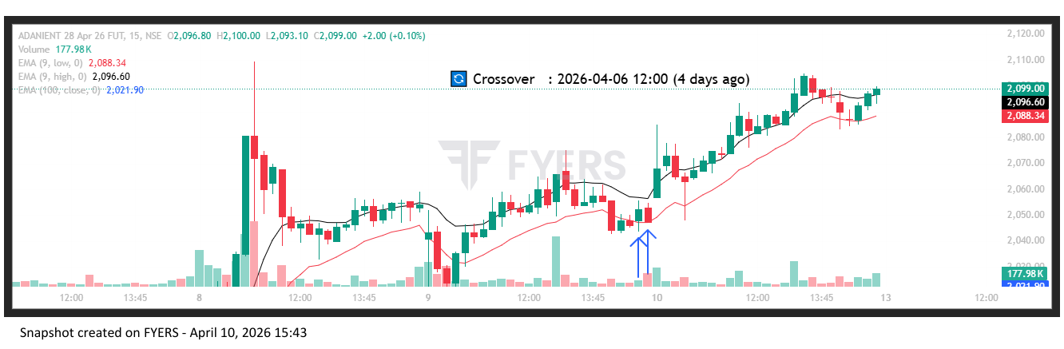
🟢 BULLISH SIGNAL --- ADANIPORTS26AprFUT

Nifty Bias : 🔴 SHORT — Counter Trend ⚠️
Crossover : 2026-04-06 13:00 (4 days ago)
Pullback : 2026-04-09 14:45
Low ₹1451 ≤ EMA9(Low) ₹1451.37
High ₹1454.1 (breakout level)
Confirm : 2026-04-10 09:15 (+3 candle)
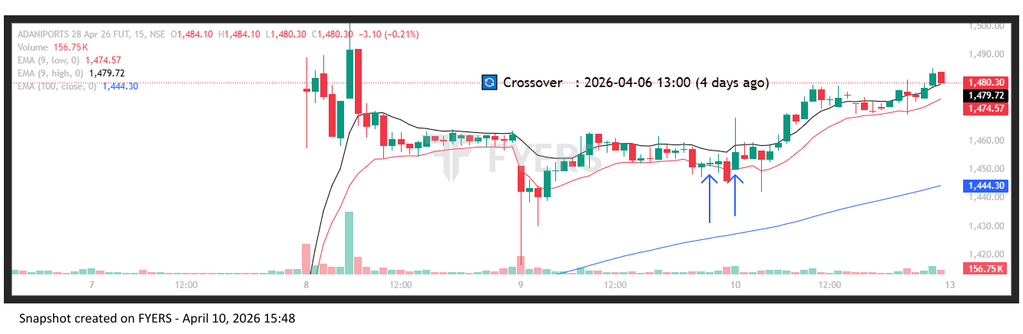
🟢 BULLISH SIGNAL --- ABCAPITAL26AprFUT

Nifty Bias : 🔴 SHORT — Counter Trend ⚠️
Crossover : 2026-04-06 10:45 (4 days ago)
Pullback : 2026-04-09 15:00
Low ₹334.15 ≤ EMA9(Low) ₹335.71
High ₹336.75 (breakout level)
Confirm : 2026-04-10 09:15 (+2 candle)
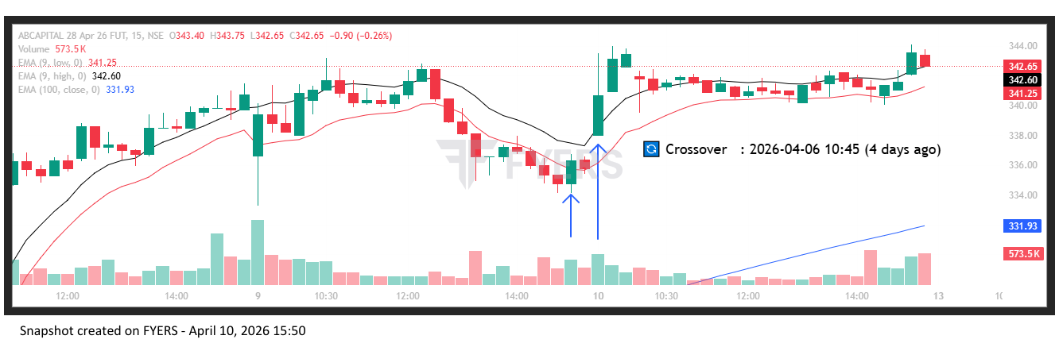
🟢 BULLISH SIGNAL --- AMBUJACEM26AprFUT

Nifty Bias : 🔴 SHORT — Counter Trend ⚠️
Crossover : 2026-04-02 15:00 (8 days ago)
Pullback : 2026-04-09 15:00
Low ₹433.75 ≤ EMA9(Low) ₹434.1
High ₹436 (breakout level)
Confirm : 2026-04-10 09:15 (+2 candle)
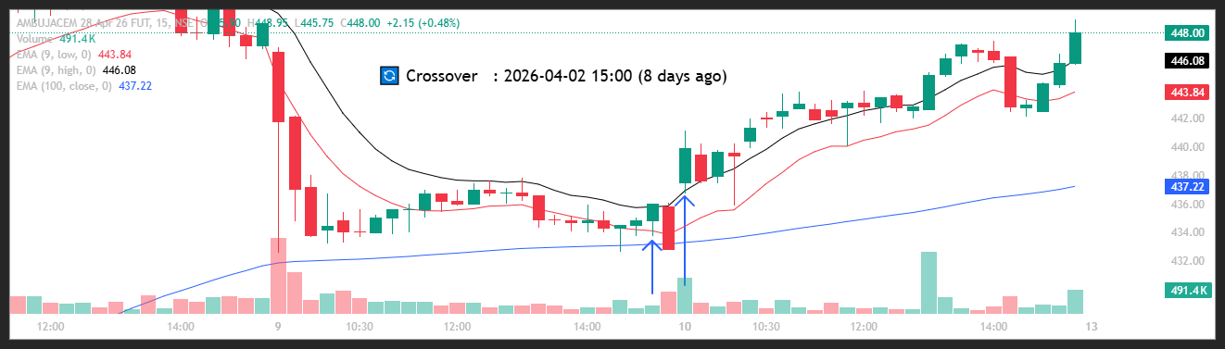
🟢 BULLISH SIGNAL --- APOLLOHOSP26AprFUT

Nifty Bias : 🔴 SHORT — Counter Trend ⚠️
Crossover : 2026-04-08 14:45 (2 days ago)
Pullback : 2026-04-09 15:00
Low ₹7474.5 ≤ EMA9(Low) ₹7475.76
High ₹7511.5 (breakout level)
Confirm : 2026-04-10 09:15 (+2 candle)
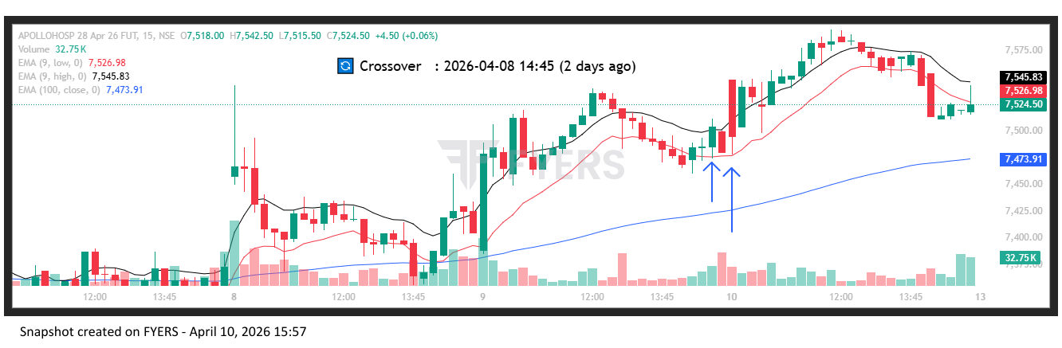
🟢 BULLISH SIGNAL --- AXISBANK26AprFUT

Nifty Bias : 🔴 SHORT — Counter Trend ⚠️
Crossover : 2026-04-06 09:15 (4 days ago)
Pullback : 2026-04-09 14:45
Low ₹1320 ≤ EMA9(Low) ₹1322.95
High ₹1323.5 (breakout level)
Confirm : 2026-04-10 09:15 (+3 candle)
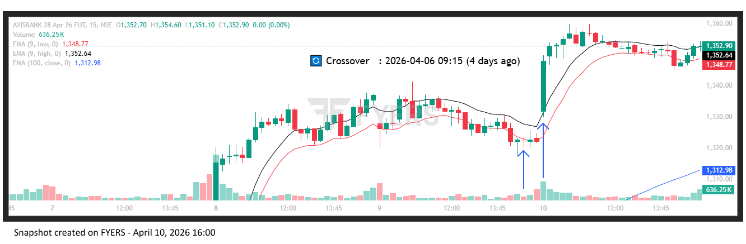
🟢 BULLISH SIGNAL --- BAJAJFINSV26AprFUT

Nifty Bias : 🔴 SHORT — Counter Trend ⚠️
Crossover : 2026-04-07 11:45 (3 days ago)
Pullback : 2026-04-09 15:00
Low ₹1766.1 ≤ EMA9(Low) ₹1768.47
High ₹1776 (breakout level)
Confirm : 2026-04-10 09:15 (+2 candle)
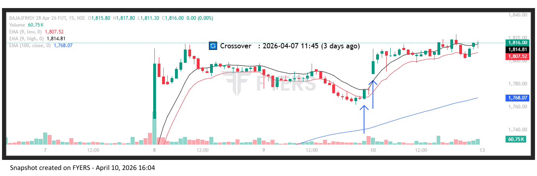
🟢 BULLISH SIGNAL --- BANKBARODA26AprFUT

Nifty Bias : 🔴 SHORT — Counter Trend ⚠️
Crossover : 2026-04-06 13:30 (4 days ago)
Pullback : 2026-04-09 15:00
Low ₹274.2 ≤ EMA9(Low) ₹274.55
High ₹275.48 (breakout level)
Confirm : 2026-04-10 09:15 (+2 candle)
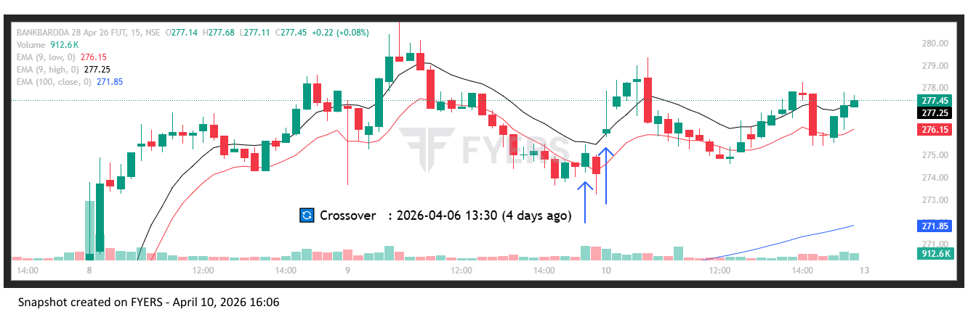
🟢 BULLISH SIGNAL --- BANKINDIA26AprFUT

Nifty Bias : 🔴 SHORT — Counter Trend ⚠️
Crossover : 2026-04-08 09:45 (2 days ago)
Pullback : 2026-04-09 15:00
Low ₹144.15 ≤ EMA9(Low) ₹144.41
High ₹144.8 (breakout level)
Confirm : 2026-04-10 09:15 (+2 candle)
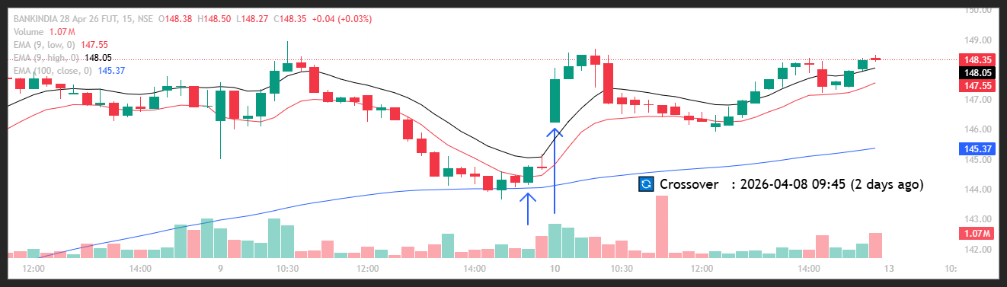
🟢 BULLISH SIGNAL --- BDL26AprFUT

Nifty Bias : 🔴 SHORT — Counter Trend ⚠️
Crossover : 2026-04-01 10:15 (9 days ago)
Pullback : 2026-04-09 15:00
Low ₹1320.6 ≤ EMA9(Low) ₹1324
High ₹1328.4 (breakout level)
Confirm : 2026-04-10 09:15 (+2 candle)
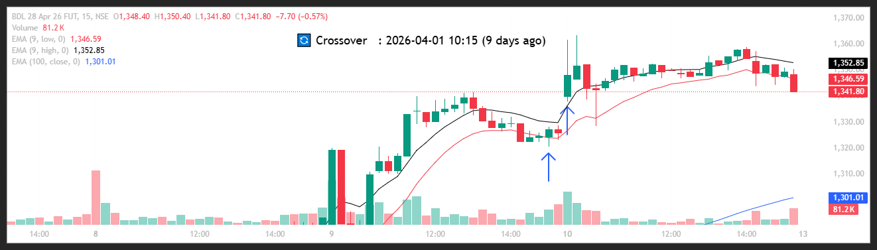
🟢 BULLISH SIGNAL --- BEL26AprFUT

Nifty Bias : 🔴 SHORT — Counter Trend ⚠️
Crossover : 2026-04-02 13:30 (8 days ago)
Pullback : 2026-04-09 15:00
Low ₹440.7 ≤ EMA9(Low) ₹441.22
High ₹442.45 (breakout level)
Confirm : 2026-04-10 09:15 (+2 candle)
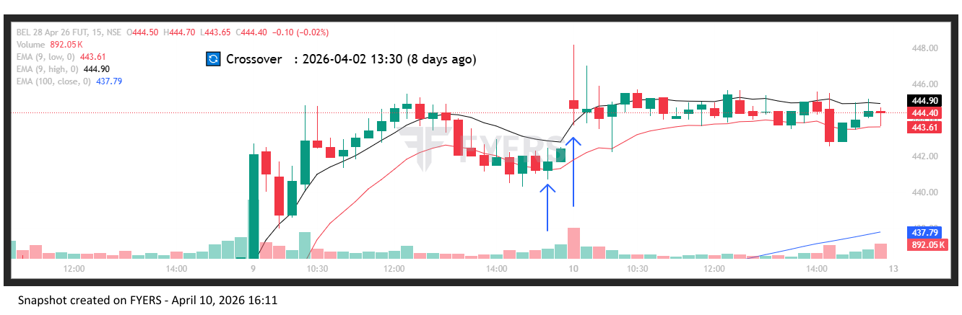
🟢 BULLISH SIGNAL --- BHARATFORG26AprFUT

Nifty Bias : 🔴 SHORT — Counter Trend ⚠️
Crossover : 2026-04-07 15:15 (3 days ago)
Pullback : 2026-04-09 15:00
Low ₹1741.7 ≤ EMA9(Low) ₹1742.58
High ₹1752 (breakout level)
Confirm : 2026-04-10 09:15 (+2 candle)

🟢 BULLISH SIGNAL --- BOSCHLTD26AprFUT

Nifty Bias : 🔴 SHORT — Counter Trend ⚠️
Crossover : 2026-04-01 10:30 (9 days ago)
Pullback : 2026-04-09 14:45
Low ₹36770 ≤ EMA9(Low) ₹36928.77
High ₹36920 (breakout level)
Confirm : 2026-04-10 09:15 (+3 candle)
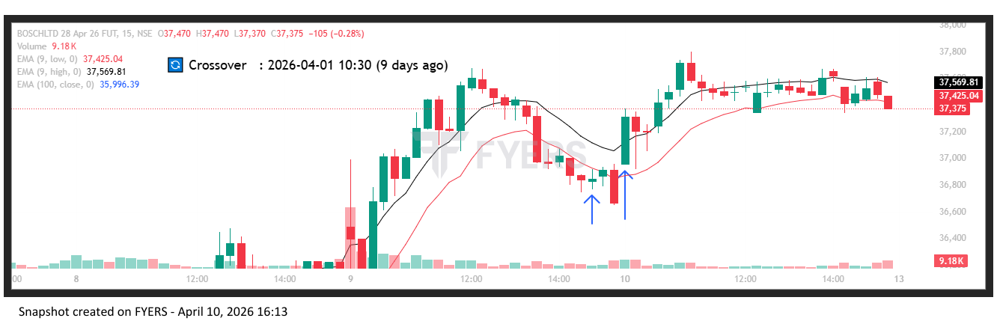
🟢 BULLISH SIGNAL --- CGPOWER26AprFUT

Nifty Bias : 🔴 SHORT — Counter Trend ⚠️
Crossover : 2026-04-02 15:00 (8 days ago)
Pullback : 2026-04-09 15:00
Low ₹720.2 ≤ EMA9(Low) ₹722.27
High ₹725.85 (breakout level)
Confirm : 2026-04-10 09:15 (+2 candle)
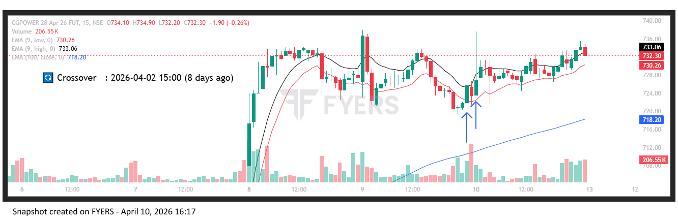
🟢 BULLISH SIGNAL --- INDIGO26AprFUT

Nifty Bias : 🔴 SHORT — Counter Trend ⚠️
Crossover : 2026-04-06 13:00 (4 days ago)
Pullback : 2026-04-09 14:45
Low ₹4458.6 ≤ EMA9(Low) ₹4480.27
High ₹4475.4 (breakout level)
Confirm : 2026-04-10 09:15 (+3 candle)
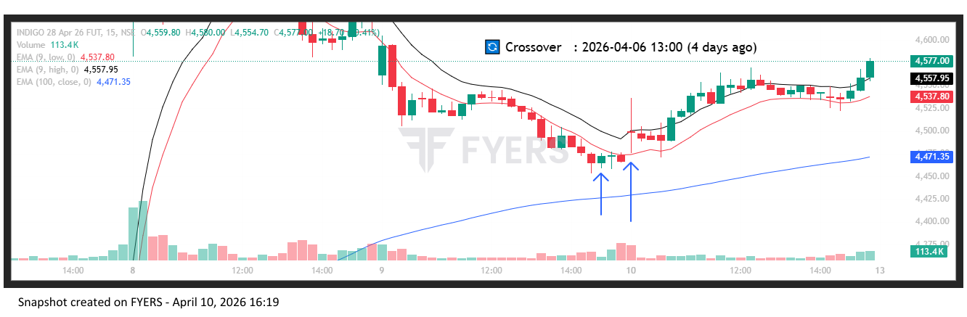
🟢 BULLISH SIGNAL --- JINDALSTEL26AprFUT

Nifty Bias : 🔴 SHORT — Counter Trend ⚠️
Crossover : 2026-04-07 10:45 (3 days ago)
Pullback : 2026-04-09 14:45
Low ₹1203.4 ≤ EMA9(Low) ₹1204.59
High ₹1207.3 (breakout level)
Confirm : 2026-04-10 09:15 (+3 candle)
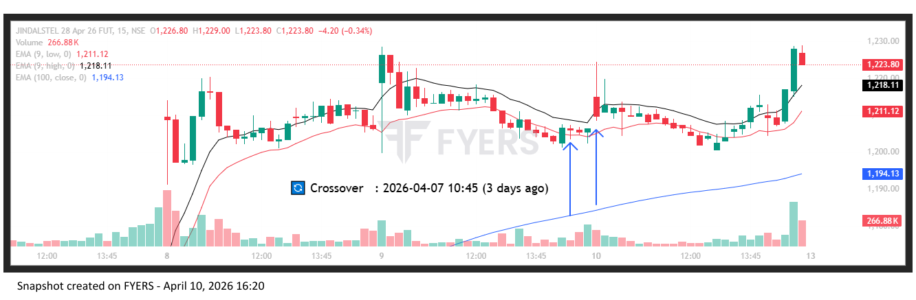
🟢 BULLISH SIGNAL --- JIOFIN26AprFUT

Nifty Bias : 🔴 SHORT — Counter Trend ⚠️
Crossover : 2026-04-06 13:00 (4 days ago)
Pullback : 2026-04-09 15:00
Low ₹239.17 ≤ EMA9(Low) ₹239.53
High ₹240.18 (breakout level)
Confirm : 2026-04-10 09:15 (+2 candle)
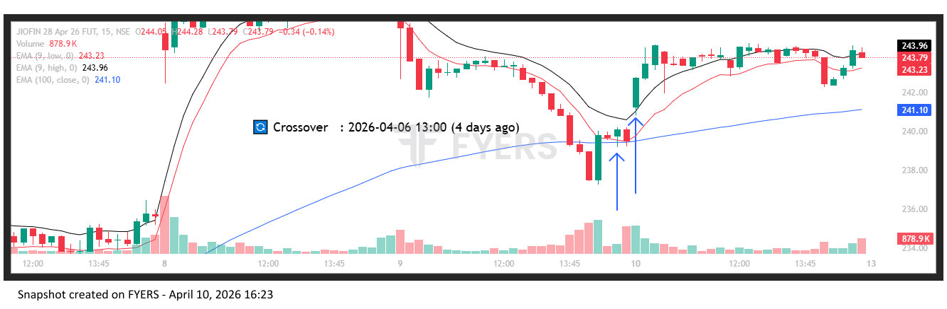
🟢 BULLISH SIGNAL --- LTF26AprFUT

Nifty Bias : 🔴 SHORT — Counter Trend ⚠️
Crossover : 2026-04-06 10:45 (4 days ago)
Pullback : 2026-04-09 14:45
Low ₹272.55 ≤ EMA9(Low) ₹273
High ₹273.82 (breakout level)
Confirm : 2026-04-10 09:15 (+3 candle)
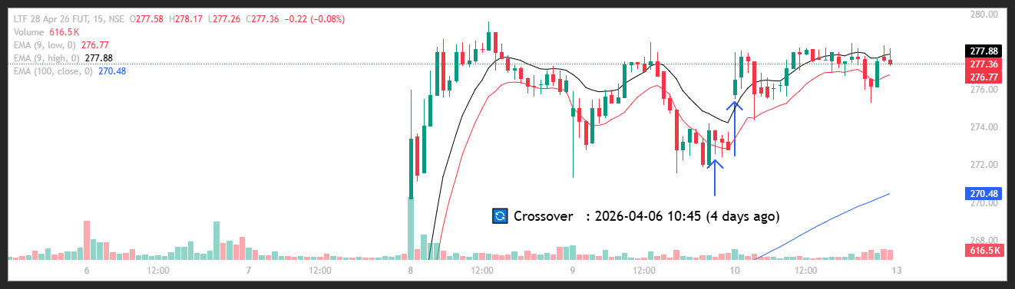
🟢 BULLISH SIGNAL --- LT26AprFUT

Nifty Bias : 🔴 SHORT — Counter Trend ⚠️
Crossover : 2026-04-02 14:45 (8 days ago)
Pullback : 2026-04-09 14:45
Low ₹3897 ≤ EMA9(Low) ₹3902.16
High ₹3911 (breakout level)
Confirm : 2026-04-10 09:15 (+3 candle)

🟢 BULLISH SIGNAL --- LAURUSLABS26AprFUT

Nifty Bias : 🔴 SHORT — Counter Trend ⚠️
Crossover : 2026-04-02 12:30 (8 days ago)
Pullback : 2026-04-09 15:00
Low ₹1083.2 ≤ EMA9(Low) ₹1083.74
High ₹1088.4 (breakout level)
Confirm : 2026-04-10 09:15 (+2 candle)

🟢 BULLISH SIGNAL --- MANAPPURAM26AprFUT

Nifty Bias : 🔴 SHORT — Counter Trend ⚠️
Crossover : 2026-04-08 09:15 (2 days ago)
Pullback : 2026-04-09 14:45
Low ₹264.2 ≤ EMA9(Low) ₹264.51
High ₹265.25 (breakout level)
Confirm : 2026-04-10 09:15 (+3 candle)

🟢 BULLISH SIGNAL --- MARUTI26AprFUT

Nifty Bias : 🔴 SHORT — Counter Trend ⚠️
Crossover : 2026-04-06 12:30 (4 days ago)
Pullback : 2026-04-09 15:00
Low ₹13584 ≤ EMA9(Low) ₹13594.5
High ₹13630 (breakout level)
Confirm : 2026-04-10 09:15 (+2 candle)

🟢 BULLISH SIGNAL --- MFSL26AprFUT

Nifty Bias : 🔴 SHORT — Counter Trend ⚠️
Crossover : 2026-04-08 09:15 (2 days ago)
Pullback : 2026-04-09 15:15
Low ₹1601.6 ≤ EMA9(Low) ₹1602.44
High ₹1615 (breakout level)
Confirm : 2026-04-10 09:15 (+1 candle)

🟢 BULLISH SIGNAL --- MAZDOCK26AprFUT

Nifty Bias : 🔴 SHORT — Counter Trend ⚠️
Crossover : 2026-04-06 10:00 (4 days ago)
Pullback : 2026-04-09 15:00
Low ₹2438.4 ≤ EMA9(Low) ₹2445.23
High ₹2452.7 (breakout level)
Confirm : 2026-04-10 09:15 (+2 candle)

🟢 BULLISH SIGNAL --- MPHASIS26AprFUT

Nifty Bias : 🔴 SHORT — Counter Trend ⚠️
Crossover : 2026-04-02 11:15 (8 days ago)
Pullback : 2026-04-09 14:45
Low ₹2386.2 ≤ EMA9(Low) ₹2387.37
High ₹2402.9 (breakout level)
Confirm : 2026-04-10 09:15 (+3 candle)

🟢 BULLISH SIGNAL --- MUTHOOTFIN26AprFUT

Nifty Bias : 🔴 SHORT — Counter Trend ⚠️
Crossover : 2026-04-06 13:15 (4 days ago)
Pullback : 2026-04-09 14:45
Low ₹3453 ≤ EMA9(Low) ₹3459.93
High ₹3462.7 (breakout level)
Confirm : 2026-04-10 09:15 (+3 candle)

🟢 BULLISH SIGNAL --- NHPC26AprFUT

Nifty Bias : 🔴 SHORT — Counter Trend ⚠️
Crossover : 2026-04-08 09:15 (2 days ago)
Pullback : 2026-04-09 15:00
Low ₹77 ≤ EMA9(Low) ₹77.08
High ₹77.33 (breakout level)
Confirm : 2026-04-10 09:15 (+2 candle)

🟢 BULLISH SIGNAL --- NTPC26AprFUT

Nifty Bias : 🔴 SHORT — Counter Trend ⚠️
Crossover : 2026-04-07 10:15 (3 days ago)
Pullback : 2026-04-09 15:15
Low ₹379 ≤ EMA9(Low) ₹379.59
High ₹381 (breakout level)
Confirm : 2026-04-10 09:15 (+1 candle)

🟢 BULLISH SIGNAL --- OBEROIRLTY26AprFUT

Nifty Bias : 🔴 SHORT — Counter Trend ⚠️
Crossover : 2026-04-02 12:15 (8 days ago)
Pullback : 2026-04-09 15:15
Low ₹1615.7 ≤ EMA9(Low) ₹1616.99
High ₹1624.4 (breakout level)
Confirm : 2026-04-10 09:15 (+1 candle)

🟢 BULLISH SIGNAL --- ONGC26AprFUT

Nifty Bias : 🔴 SHORT — Counter Trend ⚠️
Crossover : 2026-04-08 13:45 (2 days ago)
Pullback : 2026-04-09 15:00
Low ₹289.35 ≤ EMA9(Low) ₹289.36
High ₹290.5 (breakout level)
Confirm : 2026-04-10 09:15 (+2 candle)

🟢 BULLISH SIGNAL --- PAYTM26AprFUT

Nifty Bias : 🔴 SHORT — Counter Trend ⚠️
Crossover : 2026-04-06 13:00 (4 days ago)
Pullback : 2026-04-09 15:00
Low ₹1100.6 ≤ EMA9(Low) ₹1100.91
High ₹1106 (breakout level)
Confirm : 2026-04-10 09:15 (+2 candle)

🟢 BULLISH SIGNAL --- POLICYBZR26AprFUT

Nifty Bias : 🔴 SHORT — Counter Trend ⚠️
Crossover : 2026-04-07 12:45 (3 days ago)
Pullback : 2026-04-09 15:00
Low ₹1490.3 ≤ EMA9(Low) ₹1493.4
High ₹1503.2 (breakout level)
Confirm : 2026-04-10 09:15 (+2 candle)

🟢 BULLISH SIGNAL --- PRESTIGE26AprFUT

Nifty Bias : 🔴 SHORT — Counter Trend ⚠️
Crossover : 2026-04-06 12:30 (4 days ago)
Pullback : 2026-04-09 14:45
Low ₹1320.7 ≤ EMA9(Low) ₹1322.58
High ₹1328.3 (breakout level)
Confirm : 2026-04-10 09:15 (+3 candle)

🟢 BULLISH SIGNAL --- PNB26AprFUT

Nifty Bias : 🔴 SHORT — Counter Trend ⚠️
Crossover : 2026-04-08 09:15 (2 days ago)
Pullback : 2026-04-09 14:45
Low ₹109.69 ≤ EMA9(Low) ₹109.92
High ₹109.9 (breakout level)
Confirm : 2026-04-10 09:15 (+3 candle)

🟢 BULLISH SIGNAL --- CANBK26AprFUT

Nifty Bias : 🟢 LONG — Aligned ✅
Crossover : 2026-04-06 12:00 (4 days ago)
Pullback : 2026-04-09 15:00
Low ₹137.86 ≤ EMA9(Low) ₹138
High ₹138.45 (breakout level)
Confirm : 2026-04-10 09:15 (+2 candle)

🟢 BULLISH SIGNAL --- CIPLA26AprFUT

Nifty Bias : 🟢 LONG — Aligned ✅
Crossover : 2026-04-08 09:30 (2 days ago)
Pullback : 2026-04-09 14:45
Low ₹1224.7 ≤ EMA9(Low) ₹1226.15
High ₹1226.8 (breakout level)
Confirm : 2026-04-10 09:15 (+3 candle)

🟢 BULLISH SIGNAL --- COALINDIA26AprFUT

Nifty Bias : 🟢 LONG — Aligned ✅
Crossover : 2026-04-09 13:30 (20 hours ago)
Pullback : 2026-04-09 14:45
Low ₹451.65 ≤ EMA9(Low) ₹451.83
High ₹453.3 (breakout level)
Confirm : 2026-04-10 09:15 (+3 candle)

🟢 BULLISH SIGNAL --- CAMS26AprFUT

Nifty Bias : 🟢 LONG — Aligned ✅
Crossover : 2026-04-02 14:15 (8 days ago)
Pullback : 2026-04-09 15:00
Low ₹695.55 ≤ EMA9(Low) ₹696.76
High ₹699.7 (breakout level)
Confirm : 2026-04-10 09:15 (+2 candle)

🟢 BULLISH SIGNAL --- DABUR26AprFUT

Nifty Bias : 🟢 LONG — Aligned ✅
Crossover : 2026-04-08 09:15 (2 days ago)
Pullback : 2026-04-09 15:00
Low ₹429.9 ≤ EMA9(Low) ₹430.02
High ₹431.3 (breakout level)
Confirm : 2026-04-10 09:15 (+2 candle)

🟢 BULLISH SIGNAL --- DALBHARAT26AprFUT

Nifty Bias : 🟢 LONG — Aligned ✅
Crossover : 2026-04-06 10:15 (4 days ago)
Pullback : 2026-04-09 15:15
Low ₹1908 ≤ EMA9(Low) ₹1911.6
High ₹1920.8 (breakout level)
Confirm : 2026-04-10 09:15 (+1 candle)

🟢 BULLISH SIGNAL --- NYKAA26AprFUT

Nifty Bias : 🟢 LONG — Aligned ✅
Crossover : 2026-04-02 14:00 (8 days ago)
Pullback : 2026-04-09 15:15
Low ₹255.12 ≤ EMA9(Low) ₹255.53
High ₹256.93 (breakout level)
Confirm : 2026-04-10 09:15 (+1 candle)

🟢 BULLISH SIGNAL --- GAIL26AprFUT

Nifty Bias : 🟢 LONG — Aligned ✅
Crossover : 2026-04-02 14:15 (8 days ago)
Pullback : 2026-04-09 14:45
Low ₹152.86 ≤ EMA9(Low) ₹153.06
High ₹153.11 (breakout level)
Confirm : 2026-04-10 09:15 (+3 candle)

🟢 BULLISH SIGNAL --- GRASIM26AprFUT

Nifty Bias : 🟢 LONG — Aligned ✅
Crossover : 2026-04-06 14:00 (4 days ago)
Pullback : 2026-04-09 15:00
Low ₹2740.6 ≤ EMA9(Low) ₹2741.57
High ₹2750.2 (breakout level)
Confirm : 2026-04-10 09:15 (+2 candle)

🟢 BULLISH SIGNAL --- HDFCAMC26AprFUT

Nifty Bias : 🟢 LONG — Aligned ✅
Crossover : 2026-04-02 13:30 (8 days ago)
Pullback : 2026-04-09 15:15
Low ₹2518.9 ≤ EMA9(Low) ₹2522.04
High ₹2543.3 (breakout level)
Confirm : 2026-04-10 09:15 (+1 candle)

🟢 BULLISH SIGNAL --- HDFCBANK26AprFUT

Nifty Bias : 🟢 LONG — Aligned ✅
Crossover : 2026-04-06 11:45 (4 days ago)
Pullback : 2026-04-09 15:00
Low ₹797.45 ≤ EMA9(Low) ₹798.3
High ₹801.75 (breakout level)
Confirm : 2026-04-10 09:15 (+2 candle)

🟢 BULLISH SIGNAL --- HAL26AprFUT

Nifty Bias : 🟢 LONG — Aligned ✅
Crossover : 2026-04-02 15:15 (8 days ago)
Pullback : 2026-04-09 15:00
Low ₹4044.4 ≤ EMA9(Low) ₹4046.02
High ₹4059.8 (breakout level)
Confirm : 2026-04-10 09:15 (+2 candle)

🟢 BULLISH SIGNAL --- ICICIBANK26AprFUT

Nifty Bias : 🟢 LONG — Aligned ✅
Crossover : 2026-04-06 13:45 (4 days ago)
Pullback : 2026-04-09 14:45
Low ₹1283.3 ≤ EMA9(Low) ₹1285.9
High ₹1289.2 (breakout level)
Confirm : 2026-04-10 09:15 (+3 candle)

🟢 BULLISH SIGNAL --- ICICIGI26AprFUT

Nifty Bias : 🟢 LONG — Aligned ✅
Crossover : 2026-04-07 12:15 (3 days ago)
Pullback : 2026-04-09 15:15
Low ₹1773.8 ≤ EMA9(Low) ₹1775.6
High ₹1779.4 (breakout level)
Confirm : 2026-04-10 09:15 (+1 candle)

🟢 BULLISH SIGNAL --- IDFCFIRSTB26AprFUT

Nifty Bias : 🟢 LONG — Aligned ✅
Crossover : 2026-04-06 14:45 (4 days ago)
Pullback : 2026-04-09 15:00
Low ₹65.28 ≤ EMA9(Low) ₹65.31
High ₹65.59 (breakout level)
Confirm : 2026-04-10 09:15 (+2 candle)

🟢 BULLISH SIGNAL --- ITC26AprFUT

Nifty Bias : 🟢 LONG — Aligned ✅
Crossover : 2026-04-06 13:30 (4 days ago)
Pullback : 2026-04-09 14:45
Low ₹303.5 ≤ EMA9(Low) ₹303.56
High ₹304.25 (breakout level)
Confirm : 2026-04-10 09:15 (+3 candle)

🟢 BULLISH SIGNAL --- INDIANB26AprFUT

Nifty Bias : 🟢 LONG — Aligned ✅
Crossover : 2026-04-06 09:30 (4 days ago)
Pullback : 2026-04-09 15:00
Low ₹945.55 ≤ EMA9(Low) ₹945.59
High ₹948.1 (breakout level)
Confirm : 2026-04-10 09:15 (+2 candle)

🟢 BULLISH SIGNAL --- SOLARINDS26AprFUT

Nifty Bias : 🟢 LONG — Aligned ✅
Crossover : 2026-04-02 12:15 (8 days ago)
Pullback : 2026-04-09 14:45
Low ₹13955 ≤ EMA9(Low) ₹14019.13
High ₹14072 (breakout level)
Confirm : 2026-04-10 09:15 (+3 candle)

🟢 BULLISH SIGNAL --- SONACOMS26AprFUT

Nifty Bias : 🟢 LONG — Aligned ✅
Crossover : 2026-04-06 09:45 (4 days ago)
Pullback : 2026-04-09 15:00
Low ₹520.25 ≤ EMA9(Low) ₹524.84
High ₹525.85 (breakout level)
Confirm : 2026-04-10 09:15 (+2 candle)

🟢 BULLISH SIGNAL --- SUPREMEIND26AprFUT

Nifty Bias : 🟢 LONG — Aligned ✅
Crossover : 2026-04-06 13:30 (4 days ago)
Pullback : 2026-04-09 15:00
Low ₹3780.8 ≤ EMA9(Low) ₹3784.99
High ₹3800.8 (breakout level)
Confirm : 2026-04-10 09:15 (+2 candle)

🟢 BULLISH SIGNAL --- TMPV26AprFUT

Nifty Bias : 🟢 LONG — Aligned ✅
Crossover : 2026-04-07 13:30 (3 days ago)
Pullback : 2026-04-09 15:00
Low ₹333.2 ≤ EMA9(Low) ₹333.87
High ₹334.95 (breakout level)
Confirm : 2026-04-10 09:15 (+2 candle)

🟢 BULLISH SIGNAL --- TATASTEEL26AprFUT

Nifty Bias : 🟢 LONG — Aligned ✅
Crossover : 2026-04-06 11:00 (4 days ago)
Pullback : 2026-04-09 15:15
Low ₹205.8 ≤ EMA9(Low) ₹205.95
High ₹206.31 (breakout level)
Confirm : 2026-04-10 09:15 (+1 candle)

🟢 BULLISH SIGNAL --- TITAN26AprFUT

Nifty Bias : 🟢 LONG — Aligned ✅
Crossover : 2026-04-02 14:15 (8 days ago)
Pullback : 2026-04-09 15:15
Low ₹4430 ≤ EMA9(Low) ₹4440.83
High ₹4454.6 (breakout level)
Confirm : 2026-04-10 09:15 (+1 candle)

🟢 BULLISH SIGNAL --- TRENT26AprFUT

Nifty Bias : 🟢 LONG — Aligned ✅
Crossover : 2026-04-02 12:45 (8 days ago)
Pullback : 2026-04-09 15:15
Low ₹3846.8 ≤ EMA9(Low) ₹3851.64
High ₹3861.6 (breakout level)
Confirm : 2026-04-10 09:15 (+1 candle)

🟢 BULLISH SIGNAL --- ULTRACEMCO26AprFUT

Nifty Bias : 🟢 LONG — Aligned ✅
Crossover : 2026-04-06 13:30 (4 days ago)
Pullback : 2026-04-09 14:45
Low ₹11442 ≤ EMA9(Low) ₹11444.58
High ₹11485 (breakout level)
Confirm : 2026-04-10 09:15 (+3 candle)

🟢 BULLISH SIGNAL --- UNIONBANK26AprFUT

Nifty Bias : 🟢 LONG — Aligned ✅
Crossover : 2026-04-08 09:15 (2 days ago)
Pullback : 2026-04-09 15:00
Low ₹183.8 ≤ EMA9(Low) ₹184.08
High ₹184.8 (breakout level)
Confirm : 2026-04-10 09:15 (+2 candle)

🟢 BULLISH SIGNAL --- VBL26AprFUT

Nifty Bias : 🟢 LONG — Aligned ✅
Crossover : 2026-04-07 12:45 (3 days ago)
Pullback : 2026-04-09 14:45
Low ₹424.4 ≤ EMA9(Low) ₹425.13
High ₹426.15 (breakout level)
Confirm : 2026-04-10 09:15 (+3 candle)

🟢 BULLISH SIGNAL --- IDEA26AprFUT

Nifty Bias : 🟢 LONG — Aligned ✅
Crossover : 2026-04-08 09:15 (2 days ago)
Pullback : 2026-04-09 15:15
Low ₹9.16 ≤ EMA9(Low) ₹9.17
High ₹9.2 (breakout level)
Confirm : 2026-04-10 09:15 (+1 candle)

🟢 BULLISH SIGNAL --- YESBANK26AprFUT

Nifty Bias : 🟢 LONG — Aligned ✅
Crossover : 2026-04-06 10:15 (4 days ago)
Pullback : 2026-04-09 15:00
Low ₹18.95 ≤ EMA9(Low) ₹18.96
High ₹19.05 (breakout level)
Confirm : 2026-04-10 09:15 (+2 candle)

🟢 BULLISH SIGNAL --- ZYDUSLIFE26AprFUT

Nifty Bias : 🟢 LONG — Aligned ✅
Crossover : 2026-04-07 11:30 (3 days ago)
Pullback : 2026-04-09 15:00
Low ₹903.05 ≤ EMA9(Low) ₹903.08
High ₹907 (breakout level)
Confirm : 2026-04-10 09:15 (+2 candle)

🟢 BULLISH SIGNAL --- AUROPHARMA26AprFUT

Nifty Bias : 🟢 LONG — Aligned ✅
Crossover : 2026-04-09 12:15 (a day ago)
Pullback : 2026-04-10 09:15
Low ₹1340.7 ≤ EMA9(Low) ₹1341.22
High ₹1354.3 (breakout level)
Confirm : 2026-04-10 09:30 (+1 candle)

🟢 BULLISH SIGNAL --- GLENMARK26AprFUT

Nifty Bias : 🟢 LONG — Aligned ✅
Crossover : 2026-04-07 10:45 (3 days ago)
Pullback : 2026-04-10 09:15
Low ₹2160.4 ≤ EMA9(Low) ₹2162.88
High ₹2184.2 (breakout level)
Confirm : 2026-04-10 09:30 (+1 candle)

🟢 BULLISH SIGNAL --- IRFC26AprFUT

Nifty Bias : 🟢 LONG — Aligned ✅
Crossover : 2026-04-06 11:00 (4 days ago)
Pullback : 2026-04-09 15:00
Low ₹98.12 ≤ EMA9(Low) ₹98.23
High ₹98.64 (breakout level)
Confirm : 2026-04-10 09:15 (+2 candle)

🟢 BULLISH SIGNAL --- IREDA26AprFUT

Nifty Bias : 🟢 LONG — Aligned ✅
Crossover : 2026-04-06 10:45 (4 days ago)
Pullback : 2026-04-09 15:15
Low ₹122.28 ≤ EMA9(Low) ₹122.35
High ₹122.97 (breakout level)
Confirm : 2026-04-10 09:15 (+1 candle)

🟢 BULLISH SIGNAL --- INDUSINDBK26AprFUT

Nifty Bias : 🟢 LONG — Aligned ✅
Crossover : 2026-04-07 13:45 (3 days ago)
Pullback : 2026-04-09 14:45
Low ₹815.75 ≤ EMA9(Low) ₹816.94
High ₹817.9 (breakout level)
Confirm : 2026-04-10 09:15 (+3 candle)

🟢 BULLISH SIGNAL --- INOXWIND26AprFUT

Nifty Bias : 🟢 LONG — Aligned ✅
Crossover : 2026-04-06 11:15 (4 days ago)
Pullback : 2026-04-10 09:15
Low ₹85.28 ≤ EMA9(Low) ₹85.39
High ₹87.6 (breakout level)
Confirm : 2026-04-10 09:30 (+1 candle)

🟢 BULLISH SIGNAL --- MANKIND26AprFUT

Nifty Bias : 🟢 LONG — Aligned ✅
Crossover : 2026-04-06 14:15 (4 days ago)
Pullback : 2026-04-09 15:00
Low ₹2054 ≤ EMA9(Low) ₹2058.84
High ₹2066.8 (breakout level)
Confirm : 2026-04-10 09:30 (+3 candle)

🟢 BULLISH SIGNAL --- RBLBANK26AprFUT

Nifty Bias : 🟢 LONG — Aligned ✅
Crossover : 2026-04-02 14:30 (8 days ago)
Pullback : 2026-04-09 15:00
Low ₹318.05 ≤ EMA9(Low) ₹318.09
High ₹319.25 (breakout level)
Confirm : 2026-04-10 09:15 (+2 candle)

🟢 BULLISH SIGNAL --- RECLTD26AprFUT

Nifty Bias : 🟢 LONG — Aligned ✅
Crossover : 2026-04-02 14:00 (8 days ago)
Pullback : 2026-04-09 15:15
Low ₹347 ≤ EMA9(Low) ₹347.32
High ₹348.75 (breakout level)
Confirm : 2026-04-10 09:15 (+1 candle)

🟢 BULLISH SIGNAL --- SHREECEM26AprFUT

Nifty Bias : 🟢 LONG — Aligned ✅
Crossover : 2026-04-06 13:15 (4 days ago)
Pullback : 2026-04-09 15:00
Low ₹24010 ≤ EMA9(Low) ₹24017.49
High ₹24150 (breakout level)
Confirm : 2026-04-10 09:15 (+2 candle)

🟢 BULLISH SIGNAL --- MOTHERSON26AprFUT

Nifty Bias : 🟢 LONG — Aligned ✅
Crossover : 2026-04-07 12:00 (3 days ago)
Pullback : 2026-04-09 14:45
Low ₹117.19 ≤ EMA9(Low) ₹117.35
High ₹117.59 (breakout level)
Confirm : 2026-04-10 09:15 (+3 candle)

🟢 BULLISH SIGNAL --- SHRIRAMFIN26AprFUT

Nifty Bias : 🟢 LONG — Aligned ✅
Crossover : 2026-04-06 11:30 (4 days ago)
Pullback : 2026-04-09 15:00
Low ₹995.9 ≤ EMA9(Low) ₹997.15
High ₹1001.5 (breakout level)
Confirm : 2026-04-10 09:15 (+2 candle)

🟢 BULLISH SIGNAL --- TORNTPHARM26AprFUT

Nifty Bias : 🟢 LONG — Aligned ✅
Crossover : 2026-04-09 11:00 (a day ago)
Pullback : 2026-04-10 09:15
Low ₹4089.1 ≤ EMA9(Low) ₹4092.1
High ₹4111.8 (breakout level)
Confirm : 2026-04-10 09:30 (+1 candle)

🟢 BULLISH SIGNAL --- ABB26AprFUT

Nifty Bias : 🟢 LONG — Aligned ✅
Crossover : 2026-04-02 14:15 (8 days ago)
Pullback : 2026-04-09 15:15
Low ₹6614 ≤ EMA9(Low) ₹6616.22
High ₹6659.5 (breakout level)
Confirm : 2026-04-10 09:45 (+3 candle)

🟢 BULLISH SIGNAL --- BAJAJ-AUTO26AprFUT

Nifty Bias : 🟢 LONG — Aligned ✅
Crossover : 2026-04-06 11:15 (4 days ago)
Pullback : 2026-04-10 09:15
Low ₹9451.5 ≤ EMA9(Low) ₹9477.78
High ₹9673.5 (breakout level)
Confirm : 2026-04-10 09:45 (+2 candle)

🔴 BEARISH SIGNAL --- BRITANNIA26AprFUT

Nifty Bias : 🟢 LONG — Counter Trend ⚠️
Crossover : 2026-04-09 13:15 (21 hours ago)
Pullback : 2026-04-10 09:30
High ₹5520 ≥ EMA9(High) ₹5509.18
Low ₹5477 (breakdown level)
Confirm : 2026-04-10 09:45 (+1 candle)

🟢 BULLISH SIGNAL --- HINDUNILVR26AprFUT

Nifty Bias : 🟢 LONG — Aligned ✅
Crossover : 2026-04-07 14:30 (3 days ago)
Pullback : 2026-04-10 09:15
Low ₹2130.1 ≤ EMA9(Low) ₹2134.29
High ₹2162.9 (breakout level)
Confirm : 2026-04-10 09:45 (+2 candle)

🟢 BULLISH SIGNAL --- KALYANKJIL26AprFUT

Nifty Bias : 🟢 LONG — Aligned ✅
Crossover : 2026-04-02 14:30 (8 days ago)
Pullback : 2026-04-10 09:30
Low ₹445.25 ≤ EMA9(Low) ₹446.48
High ₹449.1 (breakout level)
Confirm : 2026-04-10 09:45 (+1 candle)

🟢 BULLISH SIGNAL --- PETRONET26AprFUT

Nifty Bias : 🟢 LONG — Aligned ✅
Crossover : 2026-04-07 14:00 (3 days ago)
Pullback : 2026-04-10 09:30
Low ₹270.06 ≤ EMA9(Low) ₹270.73
High ₹271.74 (breakout level)
Confirm : 2026-04-10 09:45 (+1 candle)

🟢 BULLISH SIGNAL --- SAIL26AprFUT

Nifty Bias : 🟢 LONG — Aligned ✅
Crossover : 2026-04-02 13:30 (8 days ago)
Pullback : 2026-04-10 09:30
Low ₹165.42 ≤ EMA9(Low) ₹165.54
High ₹165.78 (breakout level)
Confirm : 2026-04-10 09:45 (+1 candle)

🔴 BEARISH SIGNAL --- BIOCON26AprFUT

Nifty Bias : 🟢 LONG — Counter Trend ⚠️
Crossover : 2026-04-09 09:45 (a day ago)
Pullback : 2026-04-10 09:45
High ₹350.55 ≥ EMA9(High) ₹348.89
Low ₹349.6 (breakdown level)
Confirm : 2026-04-10 10:00 (+1 candle)

🟢 BULLISH SIGNAL --- HINDALCO26AprFUT

Nifty Bias : 🟢 LONG — Aligned ✅
Crossover : 2026-04-02 13:00 (8 days ago)
Pullback : 2026-04-10 09:30
Low ₹981.6 ≤ EMA9(Low) ₹983.02
High ₹987.75 (breakout level)
Confirm : 2026-04-10 10:00 (+2 candle)

🟢 BULLISH SIGNAL --- HINDZINC26AprFUT

Nifty Bias : 🟢 LONG — Aligned ✅
Crossover : 2026-04-06 09:30 (4 days ago)
Pullback : 2026-04-10 09:30
Low ₹557.65 ≤ EMA9(Low) ₹558.03
High ₹561.95 (breakout level)
Confirm : 2026-04-10 10:00 (+2 candle)

🟢 BULLISH SIGNAL --- KPITTECH26AprFUT

Nifty Bias : 🟢 LONG — Aligned ✅
Crossover : 2026-04-02 10:45 (8 days ago)
Pullback : 2026-04-10 09:45
Low ₹707 ≤ EMA9(Low) ₹713
High ₹715.5 (breakout level)
Confirm : 2026-04-10 10:00 (+1 candle)

🟢 BULLISH SIGNAL --- MCX26AprFUT

Nifty Bias : 🟢 LONG — Aligned ✅
Crossover : 2026-04-06 09:30 (4 days ago)
Pullback : 2026-04-10 09:45
Low ₹2628.8 ≤ EMA9(Low) ₹2646.74
High ₹2648 (breakout level)
Confirm : 2026-04-10 10:00 (+1 candle)

🟢 BULLISH SIGNAL --- PAGEIND26AprFUT

Nifty Bias : 🟢 LONG — Aligned ✅
Crossover : 2026-04-01 10:15 (9 days ago)
Pullback : 2026-04-10 09:45
Low ₹35675 ≤ EMA9(Low) ₹35807.8
High ₹36000 (breakout level)
Confirm : 2026-04-10 10:00 (+1 candle)

🟢 BULLISH SIGNAL --- TATATECH26AprFUT

Nifty Bias : 🟢 LONG — Aligned ✅
Crossover : 2026-04-02 13:45 (8 days ago)
Pullback : 2026-04-10 09:45
Low ₹559.35 ≤ EMA9(Low) ₹560.14
High ₹563 (breakout level)
Confirm : 2026-04-10 10:00 (+1 candle)

🟢 BULLISH SIGNAL --- APLAPOLLO26AprFUT

Nifty Bias : 🟢 LONG — Aligned ✅
Crossover : 2026-04-08 09:30 (2 days ago)
Pullback : 2026-04-10 09:30
Low ₹2028.9 ≤ EMA9(Low) ₹2034.28
High ₹2042.5 (breakout level)
Confirm : 2026-04-10 10:15 (+3 candle)

🟢 BULLISH SIGNAL --- COLPAL26AprFUT

Nifty Bias : 🟢 LONG — Aligned ✅
Crossover : 2026-04-07 12:30 (3 days ago)
Pullback : 2026-04-10 10:00
Low ₹1906.4 ≤ EMA9(Low) ₹1912.31
High ₹1927.3 (breakout level)
Confirm : 2026-04-10 10:30 (+2 candle)

🟢 BULLISH SIGNAL --- CONCOR26AprFUT

Nifty Bias : 🟢 LONG — Aligned ✅
Crossover : 2026-04-06 10:15 (4 days ago)
Pullback : 2026-04-10 10:00
Low ₹479.8 ≤ EMA9(Low) ₹480.85
High ₹484.7 (breakout level)
Confirm : 2026-04-10 10:30 (+2 candle)

🟢 BULLISH SIGNAL --- ETERNAL26AprFUT

Nifty Bias : 🟢 LONG — Aligned ✅
Crossover : 2026-04-10 09:15 (2 hours ago)
Pullback : 2026-04-10 10:00
Low ₹238.1 ≤ EMA9(Low) ₹238.86
High ₹240.23 (breakout level)
Confirm : 2026-04-10 10:30 (+2 candle)

🟢 BULLISH SIGNAL --- HDFCLIFE26AprFUT

Nifty Bias : 🟢 LONG — Aligned ✅
Crossover : 2026-04-10 09:30 (an hour ago)
Pullback : 2026-04-10 10:00
Low ₹593 ≤ EMA9(Low) ₹593.27
High ₹599.1 (breakout level)
Confirm : 2026-04-10 10:30 (+2 candle)

🟢 BULLISH SIGNAL --- ICICIPRULI26AprFUT

Nifty Bias : 🟢 LONG — Aligned ✅
Crossover : 2026-04-07 13:45 (3 days ago)
Pullback : 2026-04-10 10:00
Low ₹545.3 ≤ EMA9(Low) ₹546.28
High ₹550.55 (breakout level)
Confirm : 2026-04-10 10:30 (+2 candle)

🟢 BULLISH SIGNAL --- KAYNES26AprFUT

Nifty Bias : 🟢 LONG — Aligned ✅
Crossover : 2026-04-06 12:00 (4 days ago)
Pullback : 2026-04-10 10:15
Low ₹3801.8 ≤ EMA9(Low) ₹3802.32
High ₹3827 (breakout level)
Confirm : 2026-04-10 10:30 (+1 candle)

🟢 BULLISH SIGNAL --- LTM26AprFUT

Nifty Bias : 🟢 LONG — Aligned ✅
Crossover : 2026-04-02 12:15 (8 days ago)
Pullback : 2026-04-10 10:15
Low ₹4404.7 ≤ EMA9(Low) ₹4441.46
High ₹4425.9 (breakout level)
Confirm : 2026-04-10 10:30 (+1 candle)

🟢 BULLISH SIGNAL --- NUVAMA26AprFUT

Nifty Bias : 🟢 LONG — Aligned ✅
Crossover : 2026-04-06 10:15 (4 days ago)
Pullback : 2026-04-10 10:00
Low ₹1302.3 ≤ EMA9(Low) ₹1303.65
High ₹1315.6 (breakout level)
Confirm : 2026-04-10 10:30 (+2 candle)

🟢 BULLISH SIGNAL --- TATACONSUM26AprFUT

Nifty Bias : 🟢 LONG — Aligned ✅
Crossover : 2026-04-06 12:45 (4 days ago)
Pullback : 2026-04-10 10:00
Low ₹1081.8 ≤ EMA9(Low) ₹1081.88
High ₹1088.7 (breakout level)
Confirm : 2026-04-10 10:30 (+2 candle)

🟢 BULLISH SIGNAL --- TATAELXSI26AprFUT

Nifty Bias : 🟢 LONG — Aligned ✅
Crossover : 2026-04-02 12:45 (8 days ago)
Pullback : 2026-04-10 10:00
Low ₹4361.7 ≤ EMA9(Low) ₹4403.28
High ₹4397.6 (breakout level)
Confirm : 2026-04-10 10:30 (+2 candle)

🟢 BULLISH SIGNAL --- UPL26AprFUT

Nifty Bias : 🟢 LONG — Aligned ✅
Crossover : 2026-04-06 12:00 (4 days ago)
Pullback : 2026-04-10 10:00
Low ₹641.85 ≤ EMA9(Low) ₹644.11
High ₹648.25 (breakout level)
Confirm : 2026-04-10 10:30 (+2 candle)

🟢 BULLISH SIGNAL --- UNITDSPR26AprFUT

Nifty Bias : 🟢 LONG — Aligned ✅
Crossover : 2026-04-09 11:30 (a day ago)
Pullback : 2026-04-10 10:00
Low ₹1252.5 ≤ EMA9(Low) ₹1252.79
High ₹1259.8 (breakout level)
Confirm : 2026-04-10 10:30 (+2 candle)

🟢 BULLISH SIGNAL --- VEDL26AprFUT

Nifty Bias : 🟢 LONG — Aligned ✅
Crossover : 2026-04-02 13:30 (8 days ago)
Pullback : 2026-04-10 10:00
Low ₹734.7 ≤ EMA9(Low) ₹736.51
High ₹740 (breakout level)
Confirm : 2026-04-10 10:30 (+2 candle)

🟢 BULLISH SIGNAL --- DMART26AprFUT

Nifty Bias : 🟢 LONG — Aligned ✅
Crossover : 2026-04-09 10:30 (a day ago)
Pullback : 2026-04-10 10:30
Low ₹4403.7 ≤ EMA9(Low) ₹4408.16
High ₹4413.2 (breakout level)
Confirm : 2026-04-10 10:45 (+1 candle)

🟢 BULLISH SIGNAL --- BSE26AprFUT

Nifty Bias : 🟢 LONG — Aligned ✅
Crossover : 2026-04-02 14:00 (8 days ago)
Pullback : 2026-04-10 10:00
Low ₹3241.1 ≤ EMA9(Low) ₹3246.02
High ₹3272.9 (breakout level)
Confirm : 2026-04-10 10:45 (+3 candle)

🟢 BULLISH SIGNAL --- BPCL26AprFUT

Nifty Bias : 🟢 LONG — Aligned ✅
Crossover : 2026-04-08 09:15 (2 days ago)
Pullback : 2026-04-10 10:00
Low ₹296.55 ≤ EMA9(Low) ₹298.14
High ₹300.4 (breakout level)
Confirm : 2026-04-10 10:45 (+3 candle)

🟢 BULLISH SIGNAL --- BLUESTARCO26AprFUT

Nifty Bias : 🟢 LONG — Aligned ✅
Crossover : 2026-04-08 09:45 (2 days ago)
Pullback : 2026-04-10 10:15
Low ₹1639.3 ≤ EMA9(Low) ₹1640.71
High ₹1652.4 (breakout level)
Confirm : 2026-04-10 10:45 (+2 candle)

🟢 BULLISH SIGNAL --- GMRAIRPORT26AprFUT

Nifty Bias : 🟢 LONG — Aligned ✅
Crossover : 2026-04-06 11:30 (4 days ago)
Pullback : 2026-04-10 10:00
Low ₹94.85 ≤ EMA9(Low) ₹95
High ₹95.79 (breakout level)
Confirm : 2026-04-10 10:45 (+3 candle)

🟢 BULLISH SIGNAL --- IEX26AprFUT

Nifty Bias : 🟢 LONG — Aligned ✅
Crossover : 2026-04-06 10:15 (4 days ago)
Pullback : 2026-04-10 10:00
Low ₹129.14 ≤ EMA9(Low) ₹129.64
High ₹130.33 (breakout level)
Confirm : 2026-04-10 10:45 (+3 candle)

🟢 BULLISH SIGNAL --- KEI26AprFUT

Nifty Bias : 🟢 LONG — Aligned ✅
Crossover : 2026-04-06 10:30 (4 days ago)
Pullback : 2026-04-10 10:00
Low ₹4405 ≤ EMA9(Low) ₹4412.56
High ₹4457 (breakout level)
Confirm : 2026-04-10 10:45 (+3 candle)

🟢 BULLISH SIGNAL --- NATIONALUM26AprFUT

Nifty Bias : 🟢 LONG — Aligned ✅
Crossover : 2026-04-09 10:15 (a day ago)
Pullback : 2026-04-10 10:15
Low ₹407.75 ≤ EMA9(Low) ₹409.65
High ₹410.35 (breakout level)
Confirm : 2026-04-10 11:00 (+3 candle)

🟢 BULLISH SIGNAL --- PFC26AprFUT

Nifty Bias : 🟢 LONG — Aligned ✅
Crossover : 2026-04-02 14:15 (8 days ago)
Pullback : 2026-04-10 10:30
Low ₹428.35 ≤ EMA9(Low) ₹428.85
High ₹430.55 (breakout level)
Confirm : 2026-04-10 11:15 (+3 candle)

🟢 BULLISH SIGNAL --- NESTLEIND26AprFUT

Nifty Bias : 🟢 LONG — Aligned ✅
Crossover : 2026-04-06 12:30 (4 days ago)
Pullback : 2026-04-10 11:15
Low ₹1233.5 ≤ EMA9(Low) ₹1233.79
High ₹1236.3 (breakout level)
Confirm : 2026-04-10 11:30 (+1 candle)

🟢 BULLISH SIGNAL --- PIDILITIND26AprFUT

Nifty Bias : 🟢 LONG — Aligned ✅
Crossover : 2026-04-08 09:15 (2 days ago)
Pullback : 2026-04-10 11:30
Low ₹1340.1 ≤ EMA9(Low) ₹1347.54
High ₹1345.7 (breakout level)
Confirm : 2026-04-10 11:45 (+1 candle)

🟢 BULLISH SIGNAL --- POWERGRID26AprFUT

Nifty Bias : 🟢 LONG — Aligned ✅
Crossover : 2026-04-06 14:45 (4 days ago)
Pullback : 2026-04-10 11:30
Low ₹300.35 ≤ EMA9(Low) ₹300.75
High ₹301.4 (breakout level)
Confirm : 2026-04-10 11:45 (+1 candle)

🟢 BULLISH SIGNAL --- DIXON26AprFUT

Nifty Bias : 🟢 LONG — Aligned ✅
Crossover : 2026-04-07 12:00 (3 days ago)
Pullback : 2026-04-10 11:15
Low ₹10640 ≤ EMA9(Low) ₹10712.97
High ₹10731 (breakout level)
Confirm : 2026-04-10 12:00 (+3 candle)

🟢 BULLISH SIGNAL --- LICHSGFIN26AprFUT

Nifty Bias : 🟢 LONG — Aligned ✅
Crossover : 2026-04-01 09:15 (9 days ago)
Pullback : 2026-04-10 11:45
Low ₹532.4 ≤ EMA9(Low) ₹532.64
High ₹533.65 (breakout level)
Confirm : 2026-04-10 12:00 (+1 candle)

🟢 BULLISH SIGNAL --- PNBHOUSING26AprFUT

Nifty Bias : 🟢 LONG — Aligned ✅
Crossover : 2026-04-06 10:15 (4 days ago)
Pullback : 2026-04-10 11:45
Low ₹869.45 ≤ EMA9(Low) ₹871.51
High ₹872.7 (breakout level)
Confirm : 2026-04-10 12:00 (+1 candle)

🟢 BULLISH SIGNAL --- PERSISTENT26AprFUT

Nifty Bias : 🟢 LONG — Aligned ✅
Crossover : 2026-04-01 09:45 (9 days ago)
Pullback : 2026-04-10 11:15
Low ₹5302.5 ≤ EMA9(Low) ₹5333.83
High ₹5322.5 (breakout level)
Confirm : 2026-04-10 12:00 (+3 candle)

🟢 BULLISH SIGNAL --- INDHOTEL26AprFUT

Nifty Bias : 🟢 LONG — Aligned ✅
Crossover : 2026-04-07 10:30 (3 days ago)
Pullback : 2026-04-10 11:45
Low ₹638.2 ≤ EMA9(Low) ₹638.87
High ₹639.95 (breakout level)
Confirm : 2026-04-10 12:00 (+1 candle)

🟢 BULLISH SIGNAL --- UNOMINDA26AprFUT

Nifty Bias : 🟢 LONG — Aligned ✅
Crossover : 2026-04-10 09:45 (3 hours ago)
Pullback : 2026-04-10 11:15
Low ₹1062.2 ≤ EMA9(Low) ₹1065.38
High ₹1065.9 (breakout level)
Confirm : 2026-04-10 12:00 (+3 candle)

🟢 BULLISH SIGNAL --- VOLTAS26AprFUT

Nifty Bias : 🟢 LONG — Aligned ✅
Crossover : 2026-04-08 10:00 (2 days ago)
Pullback : 2026-04-10 11:45
Low ₹1281.1 ≤ EMA9(Low) ₹1281.68
High ₹1287.6 (breakout level)
Confirm : 2026-04-10 12:00 (+1 candle)

🟢 BULLISH SIGNAL --- BANDHANBNK26AprFUT

Nifty Bias : 🟢 LONG — Aligned ✅
Crossover : 2026-04-06 11:45 (4 days ago)
Pullback : 2026-04-10 11:45
Low ₹167.66 ≤ EMA9(Low) ₹168.03
High ₹168.38 (breakout level)
Confirm : 2026-04-10 12:30 (+3 candle)

🟢 BULLISH SIGNAL --- NBCC26AprFUT

Nifty Bias : 🟢 LONG — Aligned ✅
Crossover : 2026-04-02 14:45 (8 days ago)
Pullback : 2026-04-10 12:00
Low ₹88.87 ≤ EMA9(Low) ₹89.14
High ₹89.07 (breakout level)
Confirm : 2026-04-10 12:30 (+2 candle)

🟢 BULLISH SIGNAL --- TIINDIA26AprFUT

Nifty Bias : 🟢 LONG — Aligned ✅
Crossover : 2026-04-07 13:00 (3 days ago)
Pullback : 2026-04-10 12:15
Low ₹2753.9 ≤ EMA9(Low) ₹2758.77
High ₹2760 (breakout level)
Confirm : 2026-04-10 12:30 (+1 candle)

🟢 BULLISH SIGNAL --- FORTIS26AprFUT

Nifty Bias : 🟢 LONG — Aligned ✅
Crossover : 2026-04-06 13:00 (4 days ago)
Pullback : 2026-04-10 12:30
Low ₹853.95 ≤ EMA9(Low) ₹854.18
High ₹855.15 (breakout level)
Confirm : 2026-04-10 12:45 (+1 candle)

🟢 BULLISH SIGNAL --- PGEL26AprFUT

Nifty Bias : 🟢 LONG — Aligned ✅
Crossover : 2026-04-08 09:45 (2 days ago)
Pullback : 2026-04-10 12:15
Low ₹481.65 ≤ EMA9(Low) ₹483.79
High ₹484.9 (breakout level)
Confirm : 2026-04-10 12:45 (+2 candle)

🟢 BULLISH SIGNAL --- KOTAKBANK26AprFUT

Nifty Bias : 🟢 LONG — Aligned ✅
Crossover : 2026-04-06 14:15 (4 days ago)
Pullback : 2026-04-10 12:45
Low ₹376.6 ≤ EMA9(Low) ₹377.38
High ₹377.75 (breakout level)
Confirm : 2026-04-10 13:15 (+2 candle)

🟢 BULLISH SIGNAL --- NMDC26AprFUT

Nifty Bias : 🟢 LONG — Aligned ✅
Crossover : 2026-04-06 09:30 (4 days ago)
Pullback : 2026-04-10 12:30
Low ₹84.36 ≤ EMA9(Low) ₹84.4
High ₹84.45 (breakout level)
Confirm : 2026-04-10 13:15 (+3 candle)

🟢 BULLISH SIGNAL --- ALKEM26AprFUT

Nifty Bias : 🟢 LONG — Aligned ✅
Crossover : 2026-04-09 10:45 (a day ago)
Pullback : 2026-04-10 13:00
Low ₹5424.5 ≤ EMA9(Low) ₹5425.04
High ₹5437 (breakout level)
Confirm : 2026-04-10 13:30 (+2 candle)

🟢 BULLISH SIGNAL --- ASTRAL26AprFUT

Nifty Bias : 🟢 LONG — Aligned ✅
Crossover : 2026-04-09 11:15 (a day ago)
Pullback : 2026-04-10 13:00
Low ₹1586.4 ≤ EMA9(Low) ₹1587.42
High ₹1590.7 (breakout level)
Confirm : 2026-04-10 13:30 (+2 candle)

🟢 BULLISH SIGNAL --- BAJFINANCE26AprFUT

Nifty Bias : 🟢 LONG — Aligned ✅
Crossover : 2026-04-06 12:30 (4 days ago)
Pullback : 2026-04-10 12:45
Low ₹916 ≤ EMA9(Low) ₹919.03
High ₹920.55 (breakout level)
Confirm : 2026-04-10 13:30 (+3 candle)

🔴 BEARISH SIGNAL --- COFORGE26AprFUT

Nifty Bias : 🟢 LONG — Counter Trend ⚠️
Crossover : 2026-04-10 11:15 (3 hours ago)
Pullback : 2026-04-10 13:15
High ₹1231.9 ≥ EMA9(High) ₹1229.94
Low ₹1228.2 (breakdown level)
Confirm : 2026-04-10 13:30 (+1 candle)

🟢 BULLISH SIGNAL --- DELHIVERY26AprFUT

Nifty Bias : 🟢 LONG — Aligned ✅
Crossover : 2026-04-06 10:45 (4 days ago)
Pullback : 2026-04-10 12:45
Low ₹470.8 ≤ EMA9(Low) ₹471.66
High ₹472.1 (breakout level)
Confirm : 2026-04-10 13:30 (+3 candle)

🟢 BULLISH SIGNAL --- SBILIFE26AprFUT

Nifty Bias : 🟢 LONG — Aligned ✅
Crossover : 2026-04-06 13:00 (4 days ago)
Pullback : 2026-04-10 12:45
Low ₹1934.4 ≤ EMA9(Low) ₹1939.25
High ₹1939 (breakout level)
Confirm : 2026-04-10 13:30 (+3 candle)

🟢 BULLISH SIGNAL --- BHARTIARTL26AprFUT

Nifty Bias : 🟢 LONG — Aligned ✅
Crossover : 2026-04-07 10:00 (3 days ago)
Pullback : 2026-04-10 13:30
Low ₹1870.6 ≤ EMA9(Low) ₹1871.7
High ₹1875.8 (breakout level)
Confirm : 2026-04-10 13:45 (+1 candle)

🟢 BULLISH SIGNAL --- INDUSTOWER26AprFUT

Nifty Bias : 🟢 LONG — Aligned ✅
Crossover : 2026-04-08 09:15 (2 days ago)
Pullback : 2026-04-10 13:15
Low ₹439.6 ≤ EMA9(Low) ₹440.31
High ₹440.85 (breakout level)
Confirm : 2026-04-10 13:45 (+2 candle)

🟢 BULLISH SIGNAL --- JSWSTEEL26AprFUT

Nifty Bias : 🟢 LONG — Aligned ✅
Crossover : 2026-04-07 14:00 (3 days ago)
Pullback : 2026-04-10 13:00
Low ₹1210.5 ≤ EMA9(Low) ₹1214.68
High ₹1212.5 (breakout level)
Confirm : 2026-04-10 13:45 (+3 candle)

🟢 BULLISH SIGNAL --- LICI26AprFUT

Nifty Bias : 🟢 LONG — Aligned ✅
Crossover : 2026-04-08 09:15 (2 days ago)
Pullback : 2026-04-10 13:00
Low ₹804.6 ≤ EMA9(Low) ₹805.25
High ₹806.25 (breakout level)
Confirm : 2026-04-10 13:45 (+3 candle)

🟢 BULLISH SIGNAL --- RELIANCE26AprFUT

Nifty Bias : 🟢 LONG — Aligned ✅
Crossover : 2026-04-10 09:45 (4 hours ago)
Pullback : 2026-04-10 13:30
Low ₹1351.6 ≤ EMA9(Low) ₹1351.66
High ₹1354 (breakout level)
Confirm : 2026-04-10 13:45 (+1 candle)

🟢 BULLISH SIGNAL --- TATAPOWER26AprFUT

Nifty Bias : 🟢 LONG — Aligned ✅
Crossover : 2026-04-06 14:00 (4 days ago)
Pullback : 2026-04-10 13:30
Low ₹396 ≤ EMA9(Low) ₹397.87
High ₹397.4 (breakout level)
Confirm : 2026-04-10 13:45 (+1 candle)

🟢 BULLISH SIGNAL --- TORNTPOWER26AprFUT

Nifty Bias : 🟢 LONG — Aligned ✅
Crossover : 2026-04-06 10:15 (4 days ago)
Pullback : 2026-04-10 13:30
Low ₹1454.4 ≤ EMA9(Low) ₹1462.02
High ₹1459 (breakout level)
Confirm : 2026-04-10 13:45 (+1 candle)

🔴 BEARISH SIGNAL --- INFY26AprFUT

Nifty Bias : 🟢 LONG — Counter Trend ⚠️
Crossover : 2026-04-10 09:45 (5 hours ago)
Pullback : 2026-04-10 13:30
High ₹1296.9 ≥ EMA9(High) ₹1291.94
Low ₹1292 (breakdown level)
Confirm : 2026-04-10 14:00 (+2 candle)

🔴 BEARISH SIGNAL --- TCS26AprFUT

Nifty Bias : 🟢 LONG — Counter Trend ⚠️
Crossover : 2026-04-10 10:45 (4 hours ago)
Pullback : 2026-04-10 13:45
High ₹2520.6 ≥ EMA9(High) ₹2512.1
Low ₹2509.5 (breakdown level)
Confirm : 2026-04-10 14:00 (+1 candle)

🔴 BEARISH SIGNAL --- TECHM26AprFUT

Nifty Bias : 🟢 LONG — Counter Trend ⚠️
Crossover : 2026-04-10 10:30 (4 hours ago)
Pullback : 2026-04-10 13:15
High ₹1445.2 ≥ EMA9(High) ₹1440.67
Low ₹1442.7 (breakdown level)
Confirm : 2026-04-10 14:00 (+3 candle)

🟢 BULLISH SIGNAL --- SAMMAANCAP26AprFUT

Nifty Bias : 🟢 LONG — Aligned ✅
Crossover : 2026-04-08 10:15 (2 days ago)
Pullback : 2026-04-10 14:00
Low ₹155.44 ≤ EMA9(Low) ₹155.52
High ₹156.1 (breakout level)
Confirm : 2026-04-10 14:15 (+1 candle)

🟢 BULLISH SIGNAL --- MARICO26AprFUT

Nifty Bias : ⚠️ CHOPPY — Choppy ⚠️
Crossover : 2026-04-10 10:15 (5 hours ago)
Pullback : 2026-04-10 14:15
Low ₹757.95 ≤ EMA9(Low) ₹758.34
High ₹761.9 (breakout level)
Confirm : 2026-04-10 14:30 (+1 candle)

🟢 BULLISH SIGNAL --- WIPRO26AprFUT

Nifty Bias : ⚠️ CHOPPY — Choppy ⚠️
Crossover : 2026-04-10 13:15 (2 hours ago)
Pullback : 2026-04-10 14:15
Low ₹200.36 ≤ EMA9(Low) ₹200.49
High ₹201.12 (breakout level)
Confirm : 2026-04-10 14:30 (+1 candle)

🟢 BULLISH SIGNAL --- ASHOKLEY26AprFUT

Nifty Bias : ⚠️ CHOPPY — Choppy ⚠️
Crossover : 2026-04-08 09:15 (2 days ago)
Pullback : 2026-04-10 14:15
Low ₹175.7 ≤ EMA9(Low) ₹176.02
High ₹177.12 (breakout level)
Confirm : 2026-04-10 14:45 (+2 candle)

🟢 BULLISH SIGNAL --- ASIANPAINT26AprFUT

Nifty Bias : ⚠️ CHOPPY — Choppy ⚠️
Crossover : 2026-04-08 09:15 (2 days ago)
Pullback : 2026-04-10 14:15
Low ₹2362.2 ≤ EMA9(Low) ₹2369.04
High ₹2375.3 (breakout level)
Confirm : 2026-04-10 14:45 (+2 candle)

🟢 BULLISH SIGNAL --- CDSL26AprFUT

Nifty Bias : ⚠️ CHOPPY — Choppy ⚠️
Crossover : 2026-04-06 10:15 (4 days ago)
Pullback : 2026-04-10 14:30
Low ₹1296 ≤ EMA9(Low) ₹1299.26
High ₹1298.5 (breakout level)
Confirm : 2026-04-10 14:45 (+1 candle)

🟢 BULLISH SIGNAL --- CHOLAFIN26AprFUT

Nifty Bias : ⚠️ CHOPPY — Choppy ⚠️
Crossover : 2026-04-06 14:15 (4 days ago)
Pullback : 2026-04-10 14:30
Low ₹1574.7 ≤ EMA9(Low) ₹1575.91
High ₹1579.6 (breakout level)
Confirm : 2026-04-10 14:45 (+1 candle)

🟢 BULLISH SIGNAL --- CROMPTON26AprFUT

Nifty Bias : ⚠️ CHOPPY — Choppy ⚠️
Crossover : 2026-04-10 10:45 (4 hours ago)
Pullback : 2026-04-10 14:30
Low ₹241.27 ≤ EMA9(Low) ₹241.91
High ₹242.03 (breakout level)
Confirm : 2026-04-10 14:45 (+1 candle)

🟢 BULLISH SIGNAL --- EXIDEIND26AprFUT

Nifty Bias : ⚠️ CHOPPY — Choppy ⚠️
Crossover : 2026-04-08 09:15 (2 days ago)
Pullback : 2026-04-10 14:30
Low ₹324 ≤ EMA9(Low) ₹324.27
High ₹324.65 (breakout level)
Confirm : 2026-04-10 14:45 (+1 candle)

🟢 BULLISH SIGNAL --- HEROMOTOCO26AprFUT

Nifty Bias : ⚠️ CHOPPY — Choppy ⚠️
Crossover : 2026-04-08 09:15 (2 days ago)
Pullback : 2026-04-10 14:15
Low ₹5443.5 ≤ EMA9(Low) ₹5457.36
High ₹5479 (breakout level)
Confirm : 2026-04-10 14:45 (+2 candle)

🟢 BULLISH SIGNAL --- HINDPETRO26AprFUT

Nifty Bias : ⚠️ CHOPPY — Choppy ⚠️
Crossover : 2026-04-08 09:15 (2 days ago)
Pullback : 2026-04-10 14:00
Low ₹359.85 ≤ EMA9(Low) ₹360.15
High ₹361.5 (breakout level)
Confirm : 2026-04-10 14:45 (+3 candle)

🟢 BULLISH SIGNAL --- IOC26AprFUT

Nifty Bias : ⚠️ CHOPPY — Choppy ⚠️
Crossover : 2026-04-08 09:15 (2 days ago)
Pullback : 2026-04-10 14:15
Low ₹142.1 ≤ EMA9(Low) ₹142.81
High ₹142.98 (breakout level)
Confirm : 2026-04-10 14:45 (+2 candle)

🟢 BULLISH SIGNAL --- KFINTECH26AprFUT

Nifty Bias : ⚠️ CHOPPY — Choppy ⚠️
Crossover : 2026-04-10 10:30 (5 hours ago)
Pullback : 2026-04-10 14:30
Low ₹905.5 ≤ EMA9(Low) ₹911.22
High ₹909.3 (breakout level)
Confirm : 2026-04-10 14:45 (+1 candle)

🟢 BULLISH SIGNAL --- MAXHEALTH26AprFUT

Nifty Bias : ⚠️ CHOPPY — Choppy ⚠️
Crossover : 2026-04-10 11:45 (3 hours ago)
Pullback : 2026-04-10 14:30
Low ₹950.3 ≤ EMA9(Low) ₹952.24
High ₹953.5 (breakout level)
Confirm : 2026-04-10 14:45 (+1 candle)

🟢 BULLISH SIGNAL --- OFSS26AprFUT

Nifty Bias : ⚠️ CHOPPY — Choppy ⚠️
Crossover : 2026-04-10 12:30 (3 hours ago)
Pullback : 2026-04-10 14:15
Low ₹7190 ≤ EMA9(Low) ₹7191.46
High ₹7243 (breakout level)
Confirm : 2026-04-10 14:45 (+2 candle)

🟢 BULLISH SIGNAL --- PIIND26AprFUT

Nifty Bias : ⚠️ CHOPPY — Choppy ⚠️
Crossover : 2026-04-09 11:45 (a day ago)
Pullback : 2026-04-10 14:15
Low ₹2936 ≤ EMA9(Low) ₹2947.45
High ₹2951 (breakout level)
Confirm : 2026-04-10 14:45 (+2 candle)

🟢 BULLISH SIGNAL --- PPLPHARMA26AprFUT

Nifty Bias : ⚠️ CHOPPY — Choppy ⚠️
Crossover : 2026-04-06 14:30 (4 days ago)
Pullback : 2026-04-10 14:15
Low ₹144.61 ≤ EMA9(Low) ₹145.53
High ₹145.56 (breakout level)
Confirm : 2026-04-10 14:45 (+2 candle)

🟢 BULLISH SIGNAL --- RVNL26AprFUT

Nifty Bias : ⚠️ CHOPPY — Choppy ⚠️
Crossover : 2026-04-02 14:00 (8 days ago)
Pullback : 2026-04-10 14:30
Low ₹270.4 ≤ EMA9(Low) ₹272.35
High ₹271.63 (breakout level)
Confirm : 2026-04-10 14:45 (+1 candle)

🟢 BULLISH SIGNAL --- SUZLON26AprFUT

Nifty Bias : ⚠️ CHOPPY — Choppy ⚠️
Crossover : 2026-04-06 12:00 (4 days ago)
Pullback : 2026-04-10 14:15
Low ₹44.93 ≤ EMA9(Low) ₹45.08
High ₹45.18 (breakout level)
Confirm : 2026-04-10 14:45 (+2 candle)

🟢 BULLISH SIGNAL --- DIVISLAB26AprFUT

Nifty Bias : ⚠️ CHOPPY — Choppy ⚠️
Crossover : 2026-04-09 11:30 (a day ago)
Pullback : 2026-04-10 14:30
Low ₹6096 ≤ EMA9(Low) ₹6103.73
High ₹6114 (breakout level)
Confirm : 2026-04-10 15:00 (+2 candle)

🟢 BULLISH SIGNAL --- EICHERMOT26AprFUT

Nifty Bias : ⚠️ CHOPPY — Choppy ⚠️
Crossover : 2026-04-08 09:30 (2 days ago)
Pullback : 2026-04-10 14:15
Low ₹7374 ≤ EMA9(Low) ₹7390.07
High ₹7425 (breakout level)
Confirm : 2026-04-10 15:00 (+3 candle)

🟢 BULLISH SIGNAL --- LODHA26AprFUT

Nifty Bias : ⚠️ CHOPPY — Choppy ⚠️
Crossover : 2026-04-06 10:15 (4 days ago)
Pullback : 2026-04-10 14:30
Low ₹820.8 ≤ EMA9(Low) ₹828.35
High ₹825.45 (breakout level)
Confirm : 2026-04-10 15:00 (+2 candle)

🟢 BULLISH SIGNAL --- M&M26AprFUT

Nifty Bias : ⚠️ CHOPPY — Choppy ⚠️
Crossover : 2026-04-08 09:15 (2 days ago)
Pullback : 2026-04-10 14:30
Low ₹3247.7 ≤ EMA9(Low) ₹3257.4
High ₹3260.7 (breakout level)
Confirm : 2026-04-10 15:00 (+2 candle)

🟢 BULLISH SIGNAL --- PATANJALI26AprFUT

Nifty Bias : ⚠️ CHOPPY — Choppy ⚠️
Crossover : 2026-04-10 13:30 (2 hours ago)
Pullback : 2026-04-10 14:30
Low ₹466.75 ≤ EMA9(Low) ₹467.5
High ₹468.5 (breakout level)
Confirm : 2026-04-10 15:00 (+2 candle)

🟢 BULLISH SIGNAL --- SBICARD26AprFUT

Nifty Bias : ⚠️ CHOPPY — Choppy ⚠️
Crossover : 2026-04-07 15:00 (3 days ago)
Pullback : 2026-04-10 14:30
Low ₹671.25 ≤ EMA9(Low) ₹674.12
High ₹672.95 (breakout level)
Confirm : 2026-04-10 15:00 (+2 candle)

🟢 BULLISH SIGNAL --- AMBER26AprFUT

Nifty Bias : 🟢 LONG — Aligned ✅
Crossover : 2026-04-07 12:15 (3 days ago)
Pullback : 2026-04-10 15:00
Low ₹7202 ≤ EMA9(Low) ₹7207.01
High ₹7229 (breakout level)
Confirm : 2026-04-10 15:15 (+1 candle)

📊 TRADING SUMMARY
━━ ALL TRADES (10-Apr) ━━━━━━━━━━━━━━━━━━━━
Total Signals | 186
Taken Trades | 11
Not Taken | 175
Balance | Rs. 1,09,75,128.40
Current Balance | Rs. 1,09,69,416.01

━━ TODAY'S LIVE TRADING (10-Apr) ━━━━━━━━━━━━━━━━━━━━
Total | 11
Completed | 11
Wins ✅ | 7
Losses ❌ | 4
Open ⏳ | 0
Win Rate | 63.6%
Net P/L | +Rs. 8,881.50 , +0.00 pts
Brokerage | Rs. 440.00
Taxes & Fees | Rs. 1854.75

━━ ALL-TIME LIVE TRADING ━━━━━━━━━━━━━━━━━━━━
Completed | 88
Wins ✅ | 48
Losses ❌ | 40
Open ⏳ | 4
Win Rate | 54.5%
Net P/L | -Rs. 5,712.41 , -82,113.75 pts
Brokerage | Rs. 3520.00
Taxes & Fees | Rs. 14134.01

━━ TODAY'S BACKTEST (10-Apr) ━━━━━━━━━━━━━━━━━━━━
Signals Today | 186
Resolved | 152
TARGET HIT ✅ | 80
SL HIT ❌ | 72
Open ⏳ | 34
Win Rate | 52.6%
Total PnL | +461.62 pts

━━ ALL-TIME BACKTEST SUMMARY ━━━━━━━━━━━━━━━━━━━━
Total Signals | 1741
TARGET HIT ✅ | 828
SL HIT ❌ | 865
Open ⏳ | 48
Win Rate | 48.9%
Total PnL | +4,462.93 pts

🤖 TRADE BEHAVIOUR ANALYSIS
✅ Trades Taken — What signals fired:
1. ADANIENSOL26AprFUT — Bullish crossover, counter-trend to Nifty. Entry ₹1106.7, SL ₹1072.05.
2. ADANIGREEN26AprFUT — Bullish crossover, counter-trend to Nifty. Entry ₹1056.55, SL ₹1044.
3. ANGELONE26AprFUT — Bullish crossover, counter-trend to Nifty. Entry ₹279.14, SL ₹276.51.
4. BHEL26AprFUT — Bullish crossover, counter-trend to Nifty. Entry ₹281.56, SL ₹276.45.
5. DLF26AprFUT — Bullish crossover, aligned with Nifty bias. Entry ₹567.05, SL ₹563.6.
6. DRREDDY26AprFUT — Bullish crossover, aligned with Nifty bias. Entry ₹1219.6, SL ₹1213.6.
7. GODREJPROP26AprFUT — Bullish crossover, aligned with Nifty bias. Entry ₹1717.8, SL ₹1693.5.
8. SIEMENS26AprFUT — Bullish crossover, aligned with Nifty bias. Entry ₹3266, SL ₹3225.4.
9. TVSMOTOR26AprFUT — Bullish crossover, aligned with Nifty bias. Entry ₹3794.2, SL ₹3721.5.
10. PHOENIXLTD26AprFUT — Bullish crossover, aligned with Nifty bias. Entry ₹1720.5, SL ₹1697.2.
11. POWERINDIA26AprFUT — Bullish crossover, aligned with Nifty bias. Entry ₹27825, SL ₹27550.
⛔ Trades Not Taken (175 signals skipped):
Counter-trend to Nifty bias — skipped (42): 360ONE26AprFUT, AUBANK26AprFUT, ADANIENT26AprFUT, ADANIPORTS26AprFUT, ABCAPITAL26AprFUT, AMBUJACEM26AprFUT, APOLLOHOSP26AprFUT, AXISBANK26AprFUT, BAJAJFINSV26AprFUT, BANKBARODA26AprFUT, BANKINDIA26AprFUT, BDL26AprFUT, BEL26AprFUT, BHARATFORG26AprFUT, BOSCHLTD26AprFUT, CGPOWER26AprFUT, INDIGO26AprFUT, JINDALSTEL26AprFUT, JIOFIN26AprFUT, LTF26AprFUT, LT26AprFUT, LAURUSLABS26AprFUT, MANAPPURAM26AprFUT, MARUTI26AprFUT, MFSL26AprFUT, MAZDOCK26AprFUT, MPHASIS26AprFUT, MUTHOOTFIN26AprFUT, NHPC26AprFUT, NTPC26AprFUT, OBEROIRLTY26AprFUT, ONGC26AprFUT, PAYTM26AprFUT, POLICYBZR26AprFUT, PRESTIGE26AprFUT, PNB26AprFUT, BRITANNIA26AprFUT, BIOCON26AprFUT, COFORGE26AprFUT, INFY26AprFUT, TCS26AprFUT, TECHM26AprFUT
Nifty choppy — skipped (24): MARICO26AprFUT, WIPRO26AprFUT, ASHOKLEY26AprFUT, ASIANPAINT26AprFUT, CDSL26AprFUT, CHOLAFIN26AprFUT, CROMPTON26AprFUT, EXIDEIND26AprFUT, HEROMOTOCO26AprFUT, HINDPETRO26AprFUT, IOC26AprFUT, KFINTECH26AprFUT, MAXHEALTH26AprFUT, OFSS26AprFUT, PIIND26AprFUT, PPLPHARMA26AprFUT, RVNL26AprFUT, SUZLON26AprFUT, DIVISLAB26AprFUT, EICHERMOT26AprFUT, LODHA26AprFUT, M&M26AprFUT, PATANJALI26AprFUT, SBICARD26AprFUT
Aligned but not entered (109): CANBK26AprFUT, CIPLA26AprFUT, COALINDIA26AprFUT, CAMS26AprFUT, DABUR26AprFUT, DALBHARAT26AprFUT, NYKAA26AprFUT, GAIL26AprFUT, GRASIM26AprFUT, HDFCAMC26AprFUT, HDFCBANK26AprFUT, HAL26AprFUT, ICICIBANK26AprFUT, ICICIGI26AprFUT, IDFCFIRSTB26AprFUT, ITC26AprFUT, INDIANB26AprFUT, SOLARINDS26AprFUT, SONACOMS26AprFUT, SUPREMEIND26AprFUT, TMPV26AprFUT, TATASTEEL26AprFUT, TITAN26AprFUT, TRENT26AprFUT, ULTRACEMCO26AprFUT, UNIONBANK26AprFUT, VBL26AprFUT, IDEA26AprFUT, YESBANK26AprFUT, ZYDUSLIFE26AprFUT, AUROPHARMA26AprFUT, GLENMARK26AprFUT, IRFC26AprFUT, IREDA26AprFUT, INDUSINDBK26AprFUT, INOXWIND26AprFUT, MANKIND26AprFUT, RBLBANK26AprFUT, RECLTD26AprFUT, SHREECEM26AprFUT, MOTHERSON26AprFUT, SHRIRAMFIN26AprFUT, TORNTPHARM26AprFUT, ABB26AprFUT, BAJAJ-AUTO26AprFUT, HINDUNILVR26AprFUT, KALYANKJIL26AprFUT, PETRONET26AprFUT, SAIL26AprFUT, HINDALCO26AprFUT, HINDZINC26AprFUT, KPITTECH26AprFUT, MCX26AprFUT, PAGEIND26AprFUT, TATATECH26AprFUT, APLAPOLLO26AprFUT, COLPAL26AprFUT, CONCOR26AprFUT, ETERNAL26AprFUT, HDFCLIFE26AprFUT, ICICIPRULI26AprFUT, KAYNES26AprFUT, LTM26AprFUT, NUVAMA26AprFUT, TATACONSUM26AprFUT, TATAELXSI26AprFUT, UPL26AprFUT, UNITDSPR26AprFUT, VEDL26AprFUT, DMART26AprFUT, BSE26AprFUT, BPCL26AprFUT, BLUESTARCO26AprFUT, GMRAIRPORT26AprFUT, IEX26AprFUT, KEI26AprFUT, NATIONALUM26AprFUT, PFC26AprFUT, NESTLEIND26AprFUT, PIDILITIND26AprFUT, POWERGRID26AprFUT, DIXON26AprFUT, LICHSGFIN26AprFUT, PNBHOUSING26AprFUT, PERSISTENT26AprFUT, INDHOTEL26AprFUT, UNOMINDA26AprFUT, VOLTAS26AprFUT, BANDHANBNK26AprFUT, NBCC26AprFUT, TIINDIA26AprFUT, FORTIS26AprFUT, PGEL26AprFUT, KOTAKBANK26AprFUT, NMDC26AprFUT, ALKEM26AprFUT, ASTRAL26AprFUT, BAJFINANCE26AprFUT, DELHIVERY26AprFUT, SBILIFE26AprFUT, BHARTIARTL26AprFUT, INDUSTOWER26AprFUT, JSWSTEEL26AprFUT, LICI26AprFUT, RELIANCE26AprFUT, TATAPOWER26AprFUT, TORNTPOWER26AprFUT, SAMMAANCAP26AprFUT, AMBER26AprFUT
📝 94% of today's signals were not acted on. 42 were counter-trend — correct discipline to avoid. 24 fired during choppy Nifty conditions — high noise, wise to skip. 109 aligned signals were not taken — review if entry was missed or risk was too high.

